Software Requirements Specification

for

SchoolFinder

**Version 1.1 approved**

**Prepared by Abhigyan Singh, Lee Cheng Han, Boon Khang, Jia Le, Ying Sheng, Jonathan**

**Team A\***

**10th April 2021**

**Table of Contents**

1. Introduction 1

1.1 Purpose 1

1.2 Document Conventions 1

1.3 Intended Audience and Reading Suggestions 1

1.4 Product Scope 2

1.5 References 3

2. Overall Description 4

2.1 Product Perspective 4

2.2 Product Functions 6

2.3 User Classes and Characteristics 7

2.4 Operating Environment 7

2.5 Design and Implementation Constraints 8

2.6 User Documentation 8

2.7 Assumptions and Dependencies 8

3. External Interface Requirements 9

3.1 User Interface 9

3.2 Hardware Interfaces 20

3.3 Software Interfaces 20

3.4 Communications Interfaces 21

4. System Features 27

4.1 Login 27

4.2 Register 28

4.3 Favourite 30

4.4 Report 31

4.5 Review 32

4.6 Search 34

4.7 Advanced Search 38

4.8 More Information 41

5. Other Nonfunctional Requirements 44

5.1 Performance Requirements 44

5.2 Safety Requirements 44

5.3 Security Requirements 44

5.4 Software Quality Attributes 45

*5.5* Business Rules 45

6. Appendix A: Glossary 46

7. Appendix B: Analysis Models 48

8. Appendix C: User Manual 50

**Revision History**

|  |  |  |  |
| --- | --- | --- | --- |
| **Name** | **Date** | **Reason For Changes** | **Version** |
| Cheng Han, Jia Le | 1 Apr 21 | Draft 1 | 1.0 |
| Cheng Han, Jia Le | 10 Apr 21 | Final Draft | 1.1 |

# Introduction

## Purpose

The purpose of this document is to provide a detailed description of the proposed mobile app, *SchoolFinder*. This document includes information on the purpose, features, and interfaces of the app as well as the design considerations for the system.

## Document Conventions

The following conventions were followed in this document write-up:

Font size: 11

Font type: Arial

Font style: Bold is used for headers and Italic is used for important names such as app or content titles.

## Intended Audience and Reading Suggestions

This SRS document is intended for the following group of people:

|  |  |
| --- | --- |
| Group | Purpose of SRS document |
| Clients | Formal documentation which serves as an assurance that the organization understands the problems to be solved and the software behaviour necessary to address these problems.  Clients may refer to the *Overall Description,* *User Interface*and *Other Nonfunctional Requirements.* |
| Developers | Formal documentation which serves as an input to the design specification built on the agreement of requirements with the client.  Developers may refer to the *Overall Description**,* *Design and Implementation Constraints**, System Features* and *Other Nonfunctional Requirements* |
| Testers | Formal documentation which serves as a guideline to develop structured testing strategies, which will be applied to the requirements for verification in the testing stage.  Testers may refer to the *Overall Description**,* *Design and Implementation Constraints**,* *User Interface**, System Features, Other Nonfunctional Requirements*, Initial Dialog Map *(References)* and *Appendix C: User Manual.* |

## Table 1: Purpose of SRS document for different stakeholders

## Product Scope

With the abundance of schools in a small country like Singapore, parents are often spoilt for choice when it comes to selecting a school for their child. When deciding the perfect school, many factors come into play such as subjects and CCAs offered, and these considerations may cause stress for parents.

*SchoolFinder* is a mobile app which serves as a one-stop service portal for parents to explore a list of schools based on several factors, which will be discussed later in this document, and to suggest the best school in their interest. S*choolFinder* aims to simplify the school searching process and allow parents to make more informed decisions based on the detailed information provided for every school.

With *SchoolFinder*, parents may no longer find the school searching process tedious and detailed information of schools are readily available and easily accessible with just a click of a button. This app will allow parents to identify their preferred school with the least amount of time and effort spent. *SchoolFinder* also provides accurate and updated information as it will be fetching publicly available government data (<https://data.gov.sg/>), which is provided by the *Ministry of Education*.

## References

|  |  |
| --- | --- |
| Use Case Model | Use Case Diagram, Use Case Description |
| Source Code | tes.zip |
| Sequence Diagrams | Search, Review, Report, Register, More information, Login, Favourites, Advanced Search |
| Dialog Map | School Finder, School Page, Registered User, Guest User, Drawer |
| PHP File | User, Report, Favourites, Comment |
| User Manual Video |  |
| Class Diagrams (jpeg + vpp) | Class Diagram (Per Use Case) |
| Work Breakdown Structure | - |
| UI Mockup | - |
| Test Cases | - |
| Meeting Minutes | - |
| Data Dictionary | - |
| System Architecture | - |

Table 2: References

# Overall Description

## Product Perspective

*SchoolFinder* is a self-contained product which relies on the Google API to retrieve map display and Government Database API to retrieve the school’s database. *SchoolFinder* also stores and retrieves user-related information in the 4 databases created using PHP, which is elaborated in *Communication Interface*. A Model-View-Control design pattern is implemented in the system architecture and a layered architecture design in the backend system. The logic flows from top-down in the hierarchy and the façade layer enables this design to be more scalable as changing one layer would not have a significant impact on another. The classes in the system also each have a single responsibility, which adds on to high cohesion and low coupling.

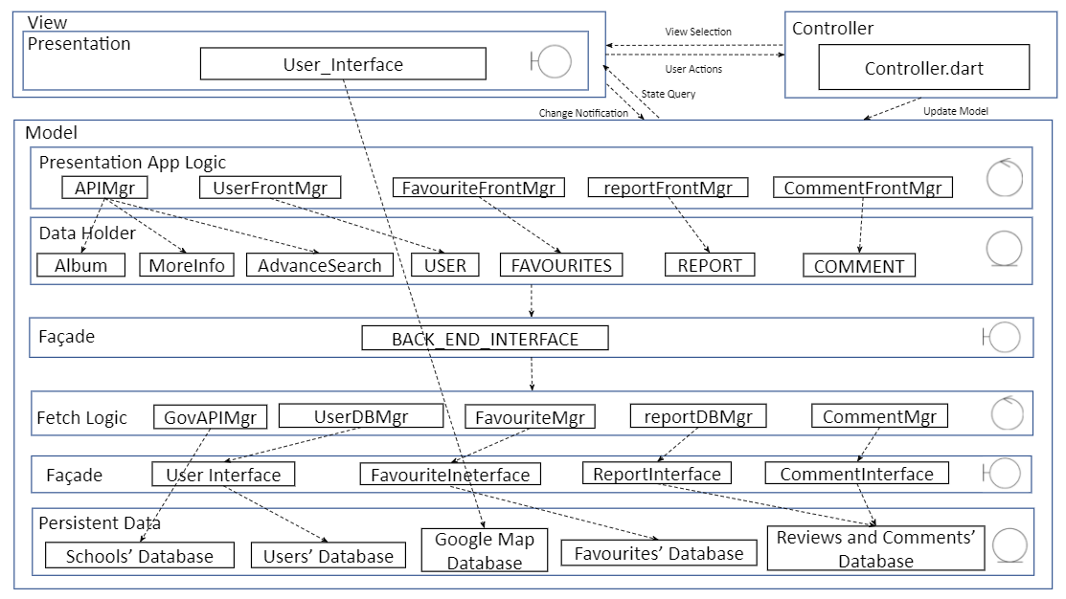

Fig 1: Layered Architecture

The following explanation details the purpose of each layer:

|  |  |
| --- | --- |
| **Layer** | **Purpose** |
| 1. Presentation | To display a user interface that the user interacts with. |
| 1. Presentation App Logic | To retrieve data from the entity classes and present it to the users on the respective screens. |
| 1. Data Holder | Comprises of entity classes used to store the information fetched from the database. |
| 1. Façade | To act as a barrier by providing more shielding and to enforce low coupling with the design. |
| 1. Fetch Logic | Comprises of control classes/managers to fetch the respective information from the database through APIs or |
| 1. Persistent Data | A collection of information that is organized to be easily accessed, managed and updated by the fetch logic. |

Table 3: Layers of System Architecture

## Product Functions

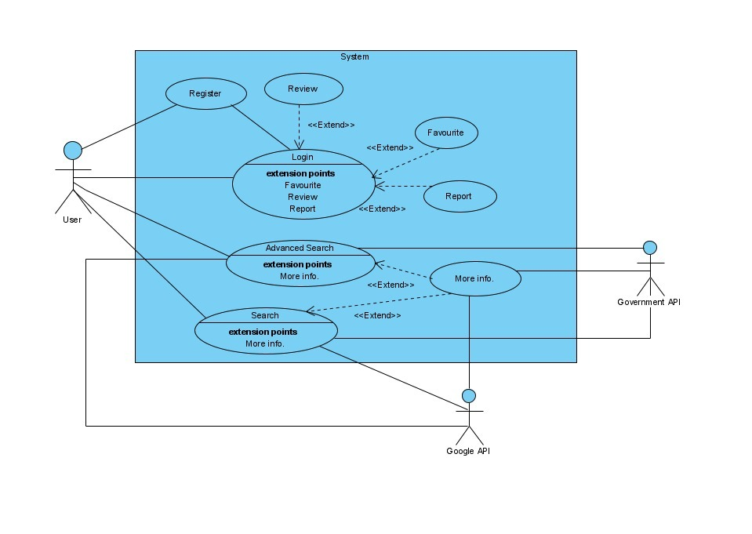

Fig 2: Use Case Diagram

*SchoolFinder* consists of the following functions that the users are able to perform:

1. User Register
   * Register new user to database
2. User Login
   * Authenticate user
3. Search
   * Allow users to search for schools through string input
   * Allow users to select matched schools to view more information
4. Advanced Search
   * Allow users to search for schools through filters such as subjects and Co-Curricular Activities (CCAs) offered
   * Allow users to select matched schools to view more information
5. More Info
   * Display detailed information of the school such as website link, email address, telephone number, address, principal’s name, transport services nearby, location on map, CCAs, subjects offered, as well as ratings and comments.
6. Review
   * Allow logged-in users to post comment and rating for the school
7. Favourite
   * Allow logged-in users to add/remove school from the favourite section
8. Report
   * Allow logged-in users to report any comments that are considered abusive behaviours

*Refer to Use Case Descriptions in *References* for further details.

## User Classes and Characteristics

The expected users of the mobile app are parents & students to search for the preferred school. There are 2 distinct user classes for this app, namely:

1. Registered/Logged-in Users:
   * Able to perform advanced searches for schools based on selected criterias.
   * Able to save their preferred school under the favourite section for future reference.
   * Able to leave comments and ratings on school pages.
   * Able to report other users for abusive behaviours.
2. Unregistered/Guest Users:
   * Able to perform normal searches for schools.

## Operating Environment

The app, *SchoolFinder* is developed in Android Studio, built using the flutter framework. It fetches relevant data from the publicly available datasets (e.g. Google Map API and data.gov.sg/ API) and MySQL database, using XAMPP. The app can be operated on a Windows/Mac laptop.

## Design and Implementation Constraints

*SchoolFinder* requires the third party API to be functioning properly such as Google Map API and data.gov.sg API. A stable internet connection is necessary for the app to retrieve the data from these API over the internet. In the event of a scheduled maintenance of these third party databases, *SchoolFinder* may experience a downtime as data is fetched in real-time.

In addition, any modifications of these databases may pose challenges to the performance of the app. For instance, the removal of a particular field may result in fetching and displaying errors of the associated data on the app. On the other hand, the addition of new entries in the database may lead to a higher latency for displaying the fetched data on the app. This app should be designed carefully to ensure that its performance fulfil the nonfunctional requirements stated in *Performance Requirements**.*

For MySQL database, Username is the primary key in most tables. It is important to maintain referential integrity to ensure that “INSERT” or “UPDATE” SQL statements, which involves changing the value of other attributes will work. A lack of referential integrity in a database can lead to incomplete data being returned, usually with no indication of an error.

## User Documentation

Refer to *Appendix C: User Manua**l* for the user guide to navigate the app.

## Assumptions and Dependencies

* Users have a stable internet connection on their devices
* The third-party APIs are working and not under maintenance
* Connections to the MySQL databases and APIs are successful

# 

# External Interface Requirements

## User Interface

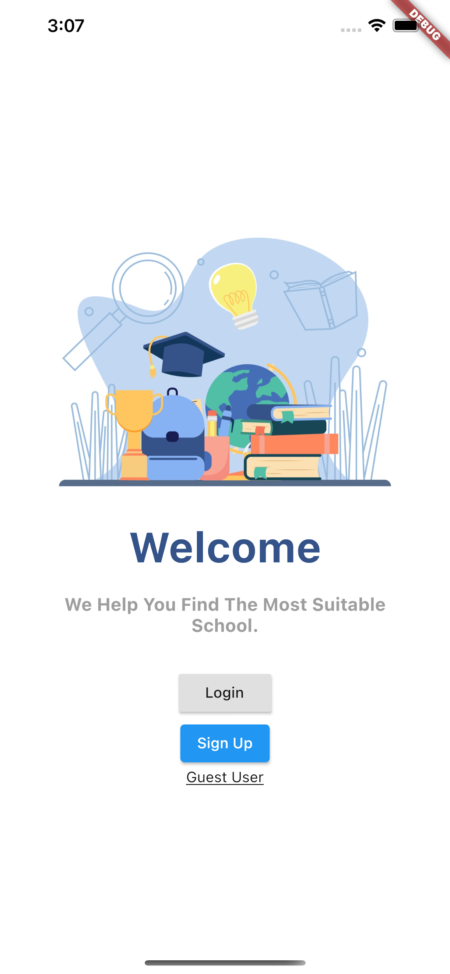

**Selection of user type page**:

Users have the choice to login as an existing user, sign up as a new user or use the app as a guest user.

**Scenario 1: User chooses Sign up option**

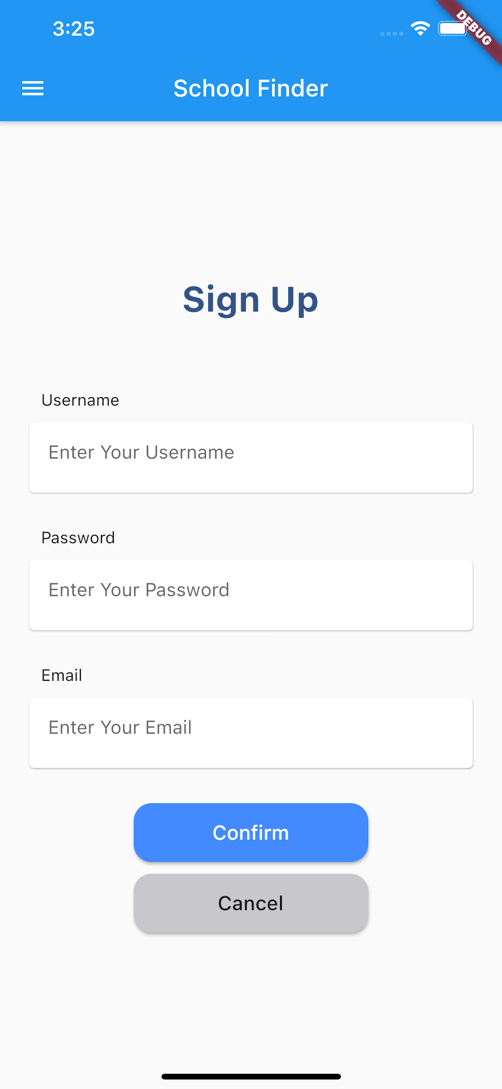**Sign up Page:**

This page allows the user to become registered with the app to get access to some extra features. After entering the required details the user can press the “confirm” button and this will take them to the login page.

**Scenario 2: User chooses Login option**

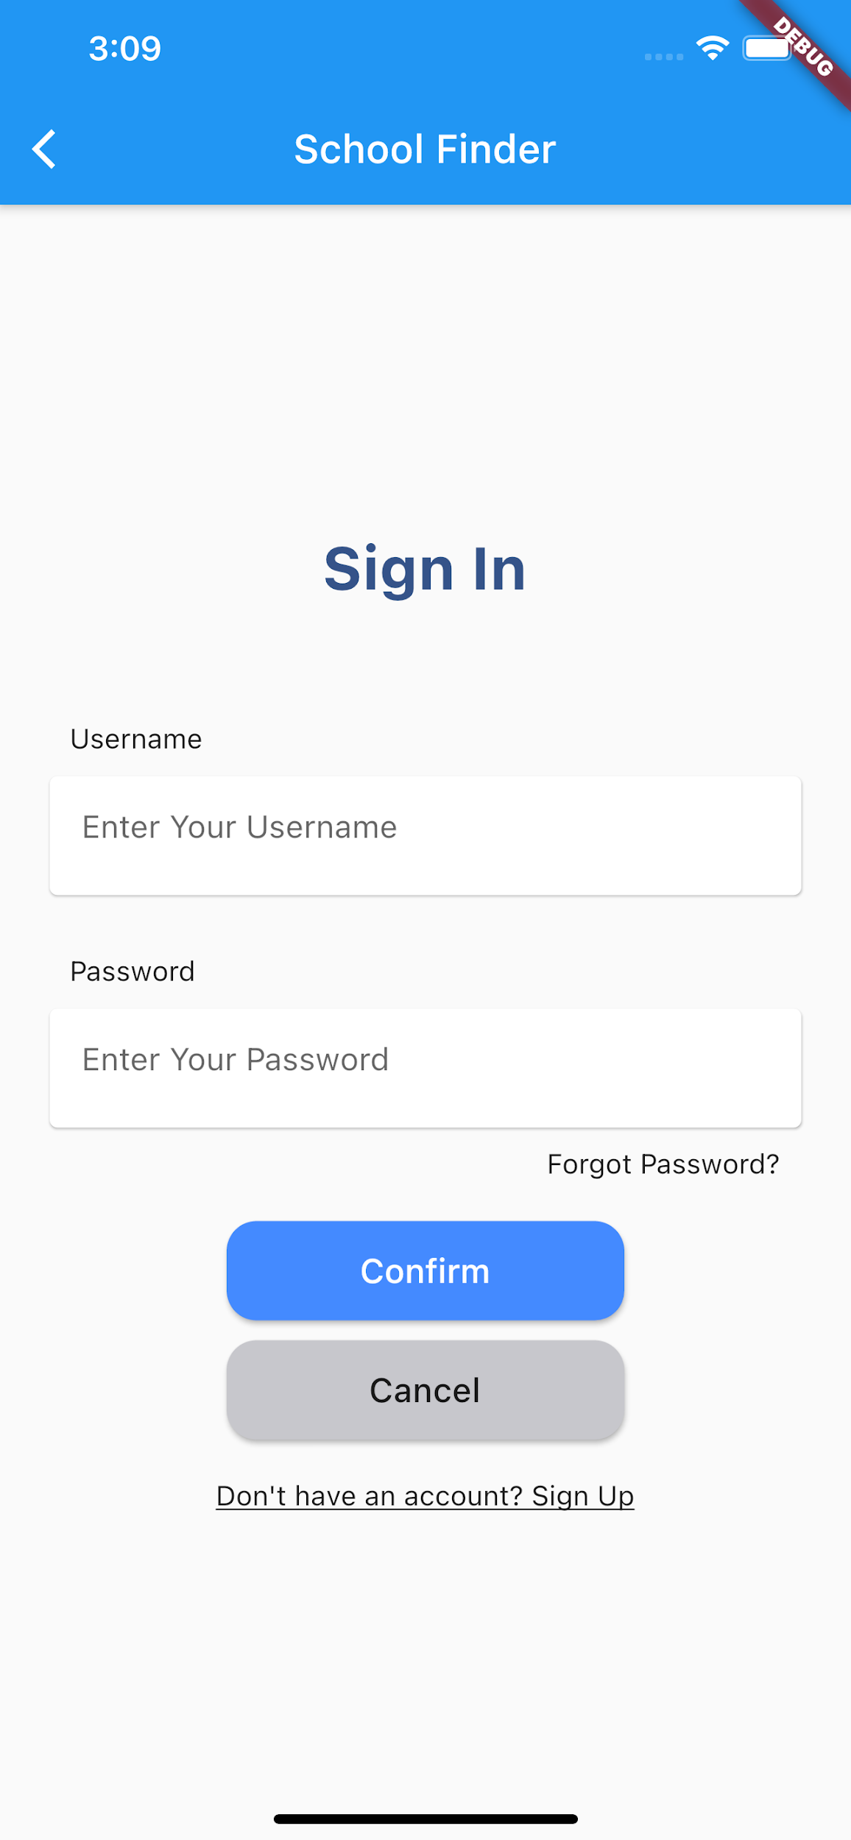**Sign in page:**

This page allows registered users to enter their details and if their details are verified and authenticated in the database, they are allowed access and will be brought to the home page.

If the details do not match, the users will be prompted that the details entered are invalid.

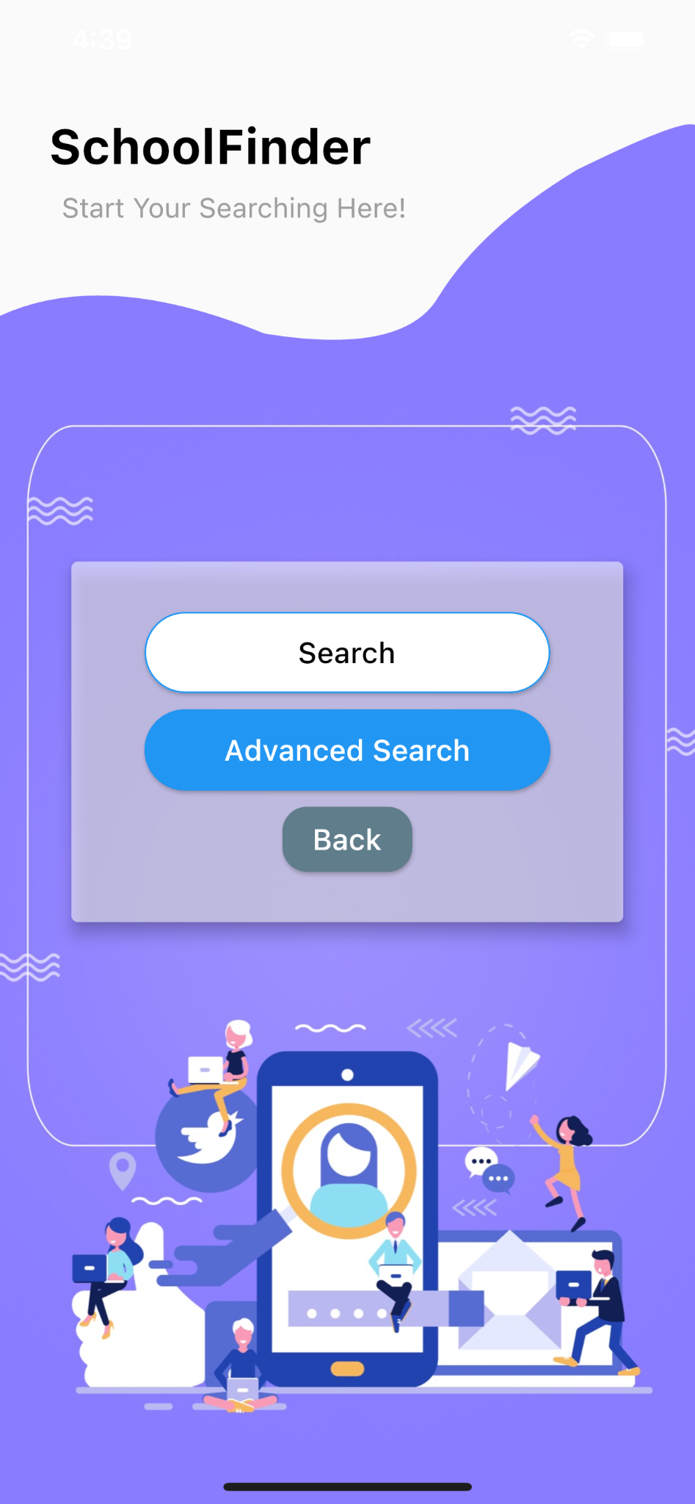

**Home Page:**

This page provides the user with 2 options: Advance Search or Search. If Search is chosen, the user will be taken to the Search page and if the Advanced Search is chosen, the user will be taken to the Advanced Search page.

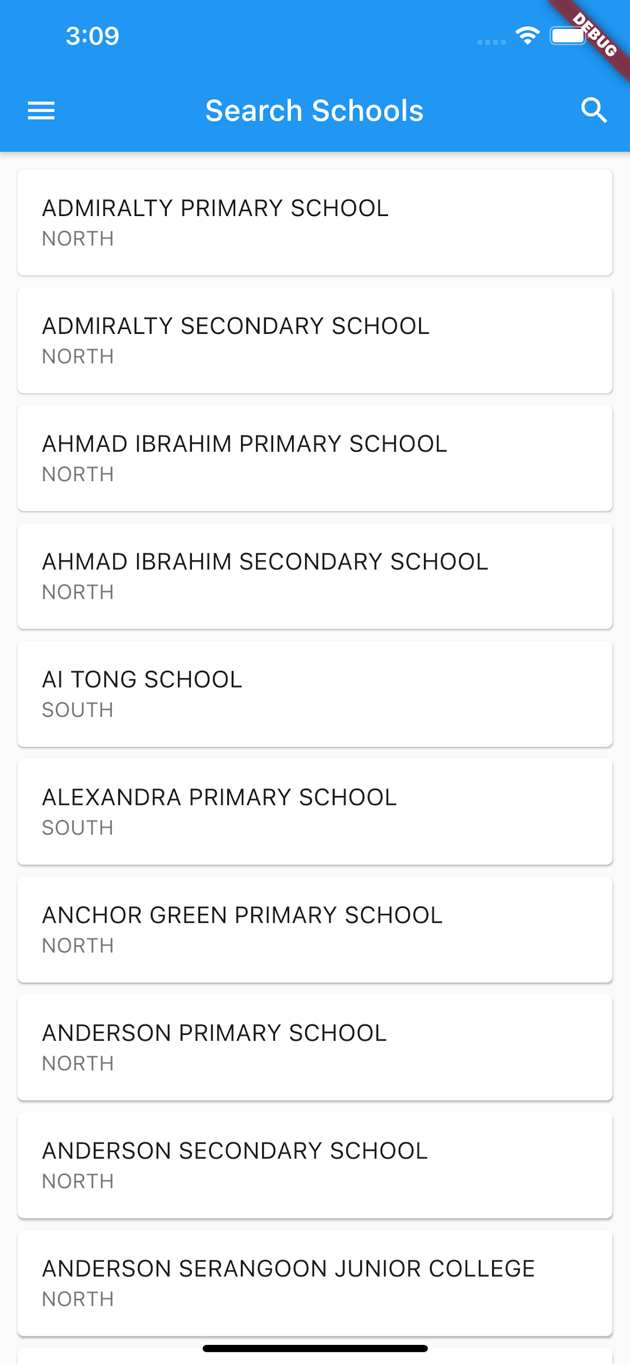

**Search page:**

This page displays a list of all the schools for the user. The user can click on any school to go to the More Info page of that school.

This page also has the option of searching for a school by clicking on the top right search button.

In addition, the top left icon will display a Drawer Navigator page for logged in users.

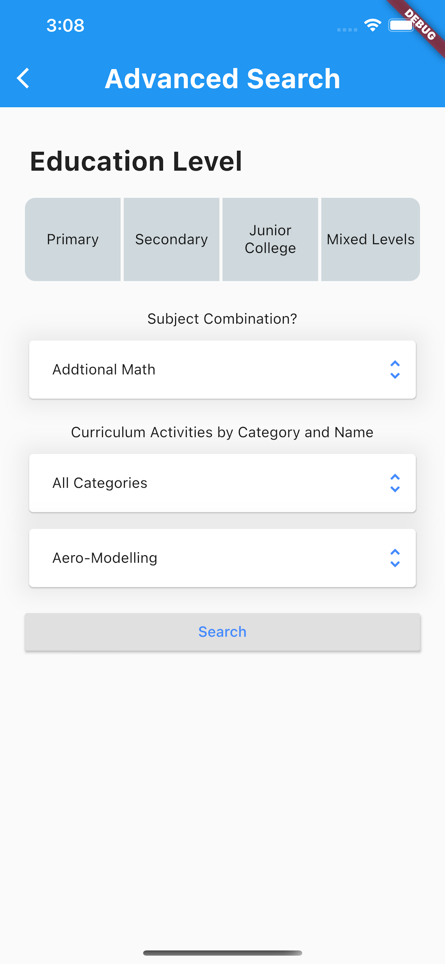

**Advanced Search Page:**

This page allows the user to filter the school list based on certain parameters like education level, subject combination etc. Upon clicking search, the app displays the list of schools filtered by these parameters.

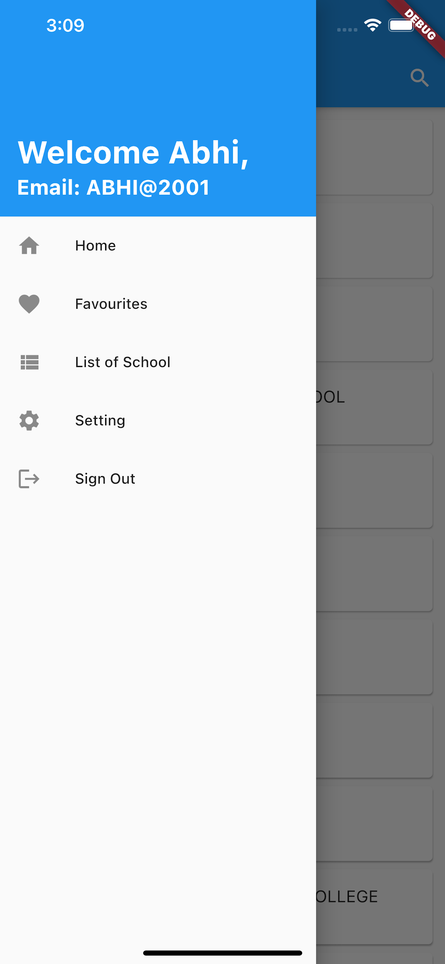

**Drawer Navigator:**

This drawer navigator is available for the logged in users and provides some extra functions:

1. Home : Takes users back to the home page.
2. Favourites : Displays a list of favourite schools that the user

has added.

1. List of Schools: Displays a list of all the schools.
2. Settings: Allows the users to change password, email and

postal code.

1. Sign out: Takes users back to the first screen of selecting the user type.

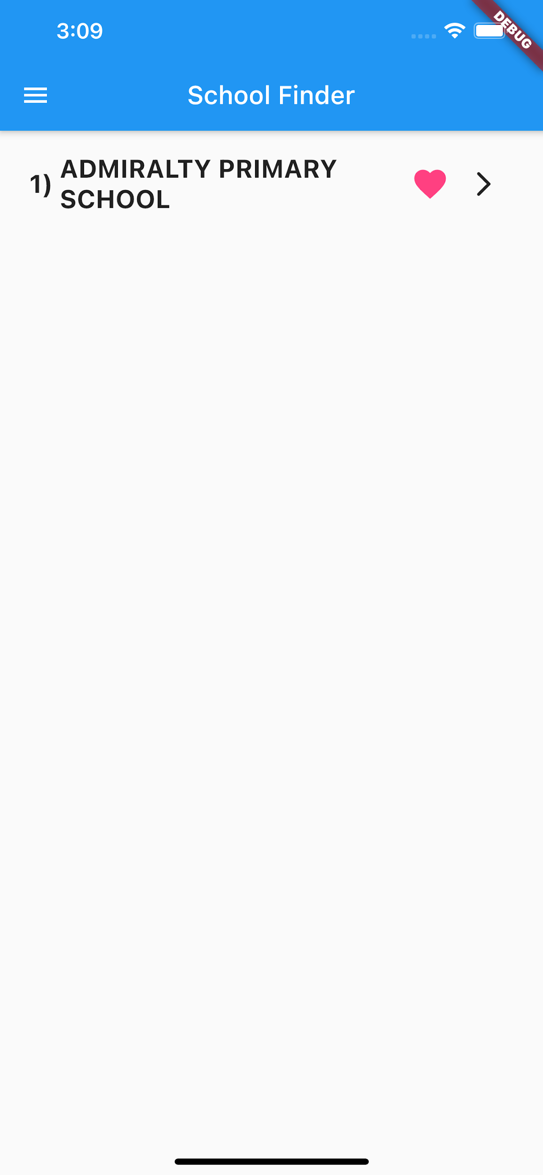

**Favourites page:**

This page can be reached by the logged in users through the Drawer Navigator. This displays the list of schools saved by the user in the Favorites list, obtained from the database. The arrow button takes the user to the More Info page of the school.

Also there is a like button at the top right and if the user clicks on it, it will add this school to the users’ Favourites list. Here it is already highlighted as this school is already added to the users’ Favourites list. Pressing this like button again will deselect the school and remove it from the user’s Favourite list.

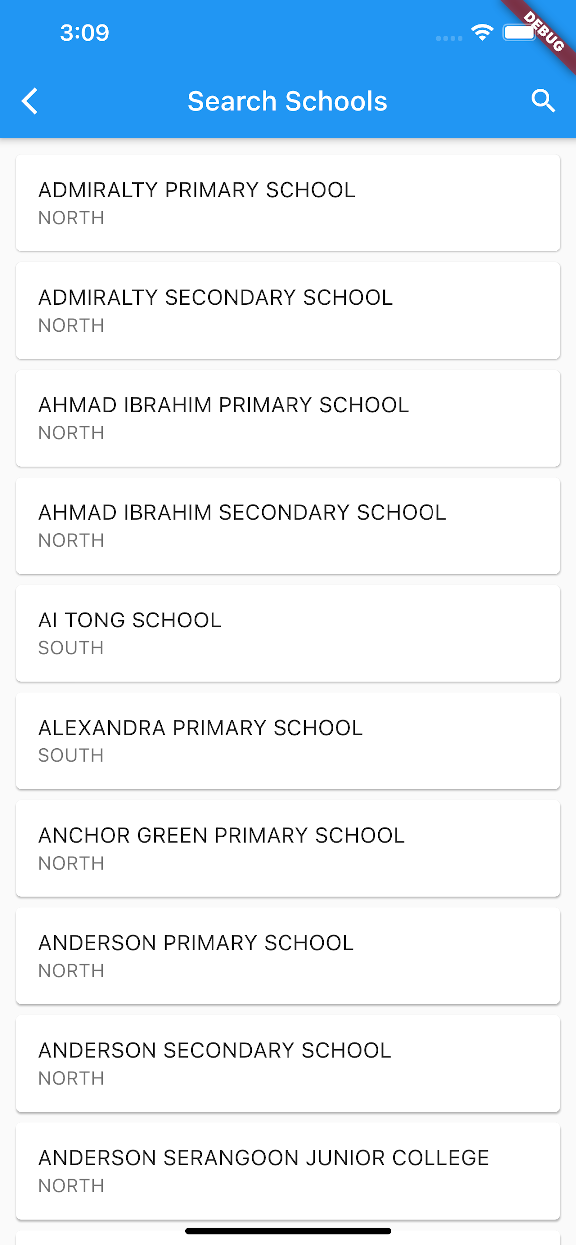

**List of Schools:**

This page just displays a list of all the schools.

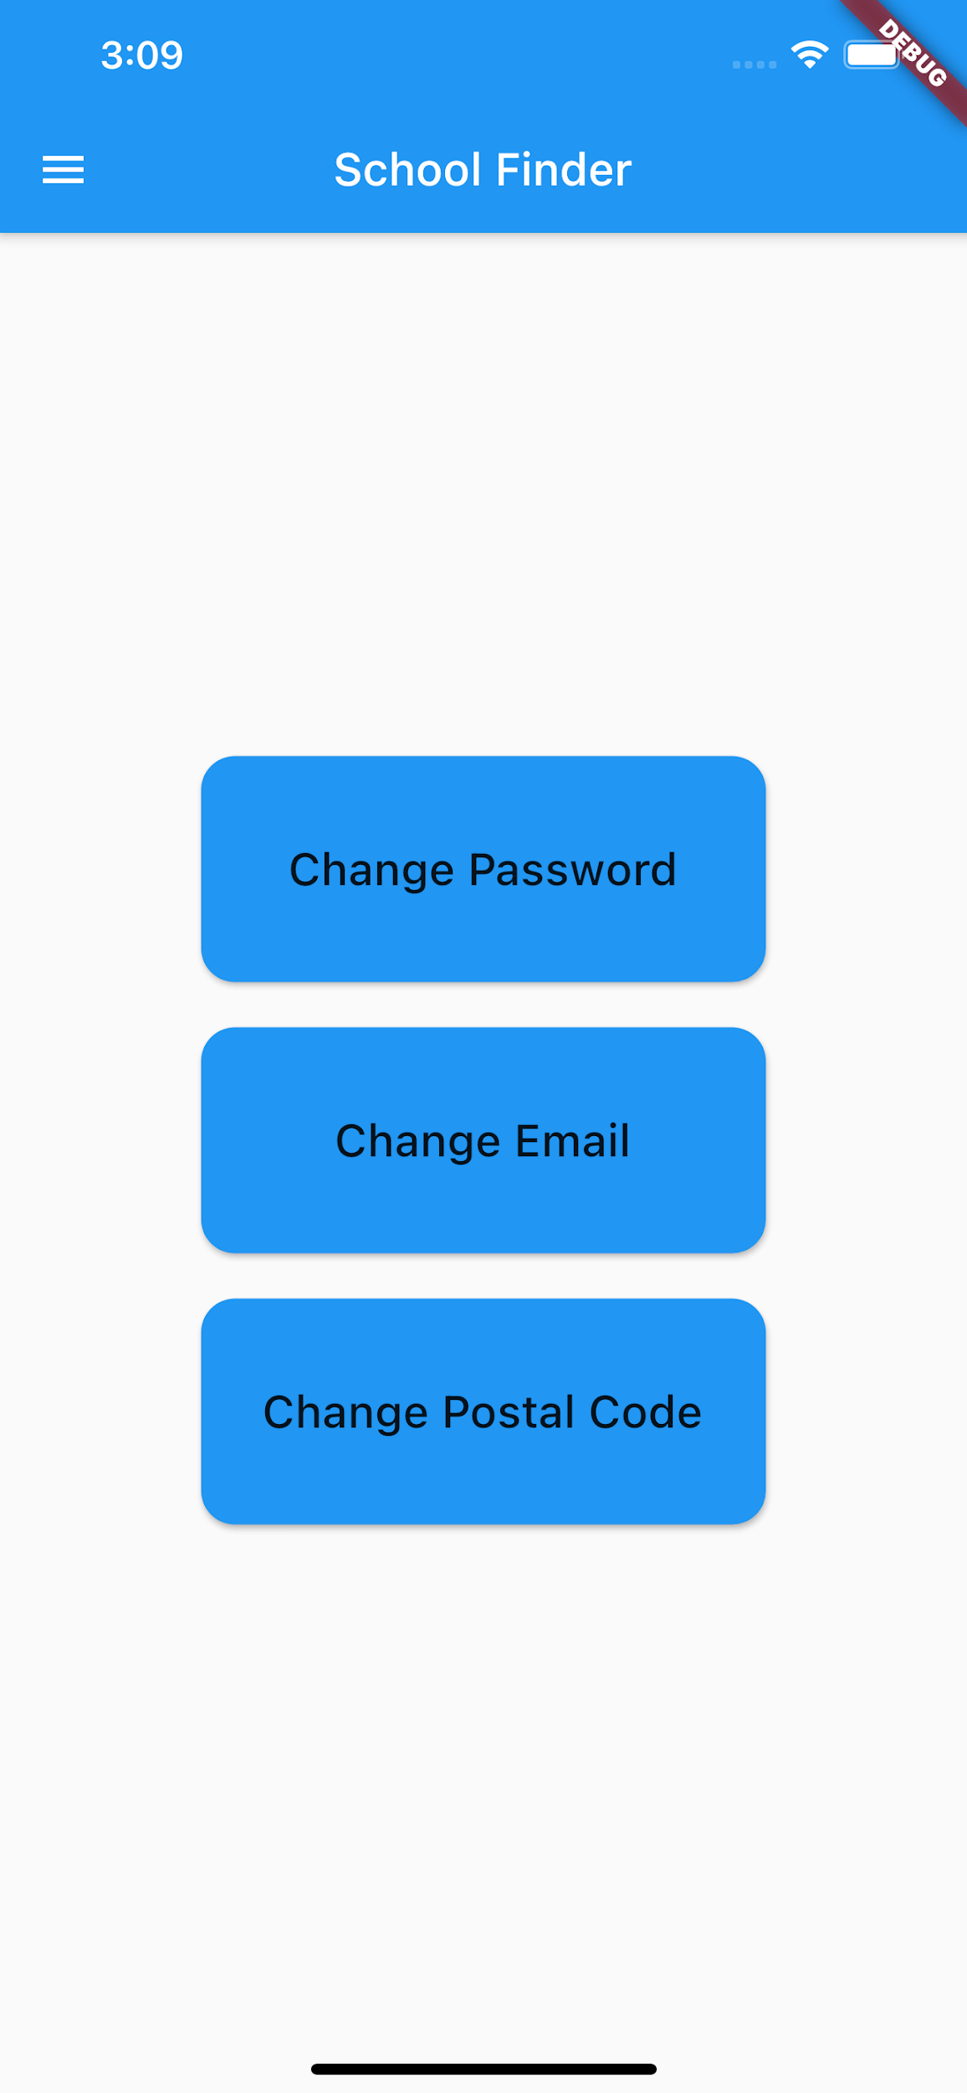

**Settings Page:**

This page allows the logged-in users to change password, email and postal code. Clicking on any of the buttons takes the user to the change page.

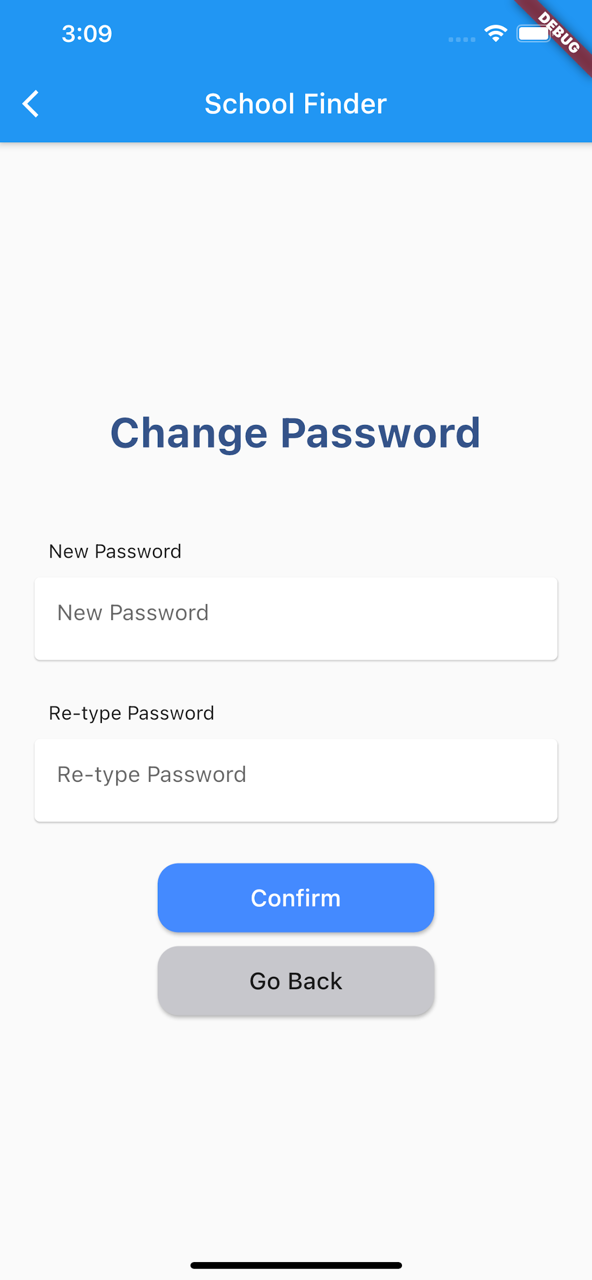

**Change Password Page:**

This page asks the user to enter these two input fields and then changes the details according to what they input.

**Scenario 3: User chooses guest option**

After pressing the guest option the user is taken to the home screen to search for the schools.

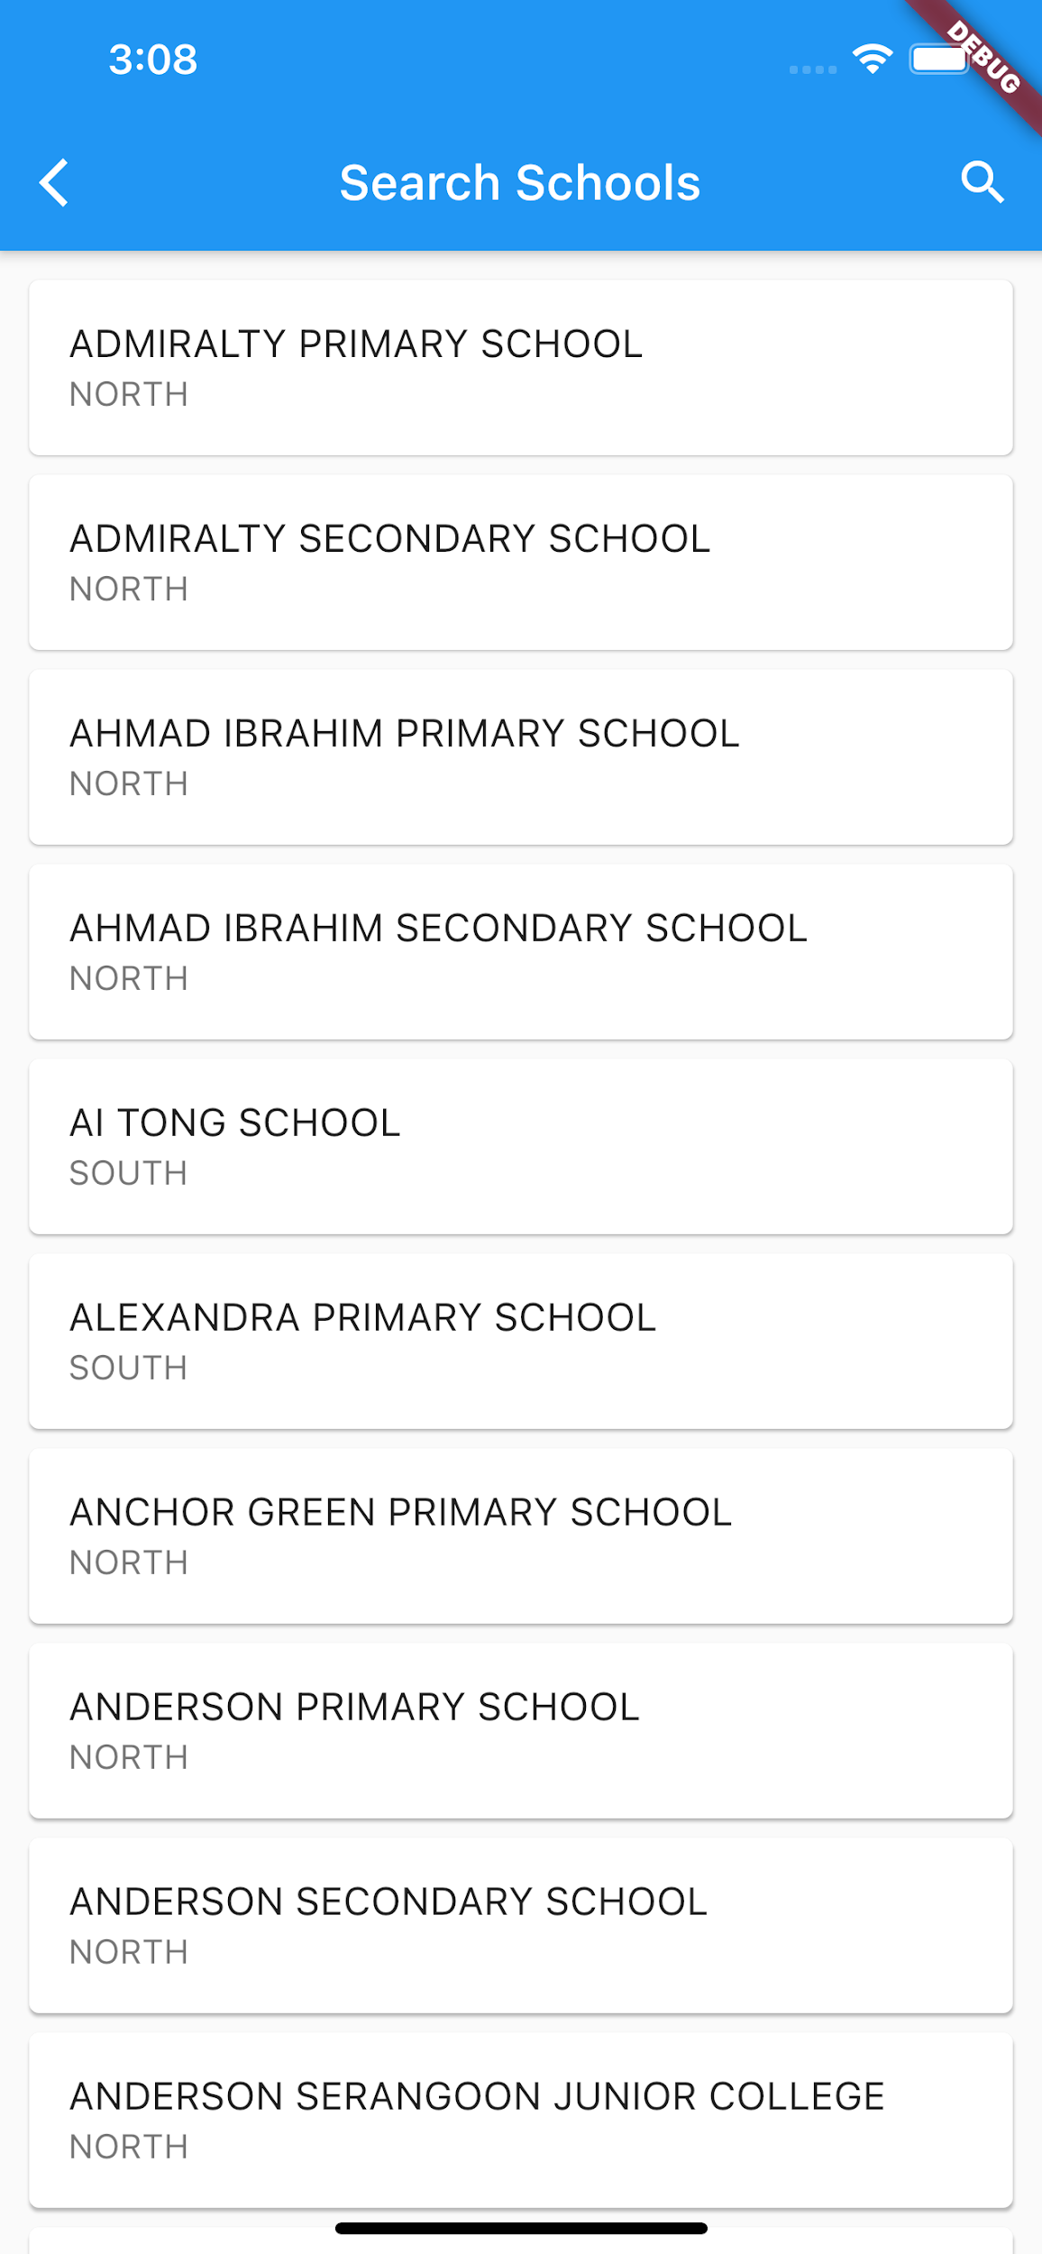

**Search page:**

This page is the same as that of the logged in user. The only difference is that guest users only have the back button instead of the Drawer Navigator.

**More Info Page**

**Scenario 1: More info Page for logged in users**

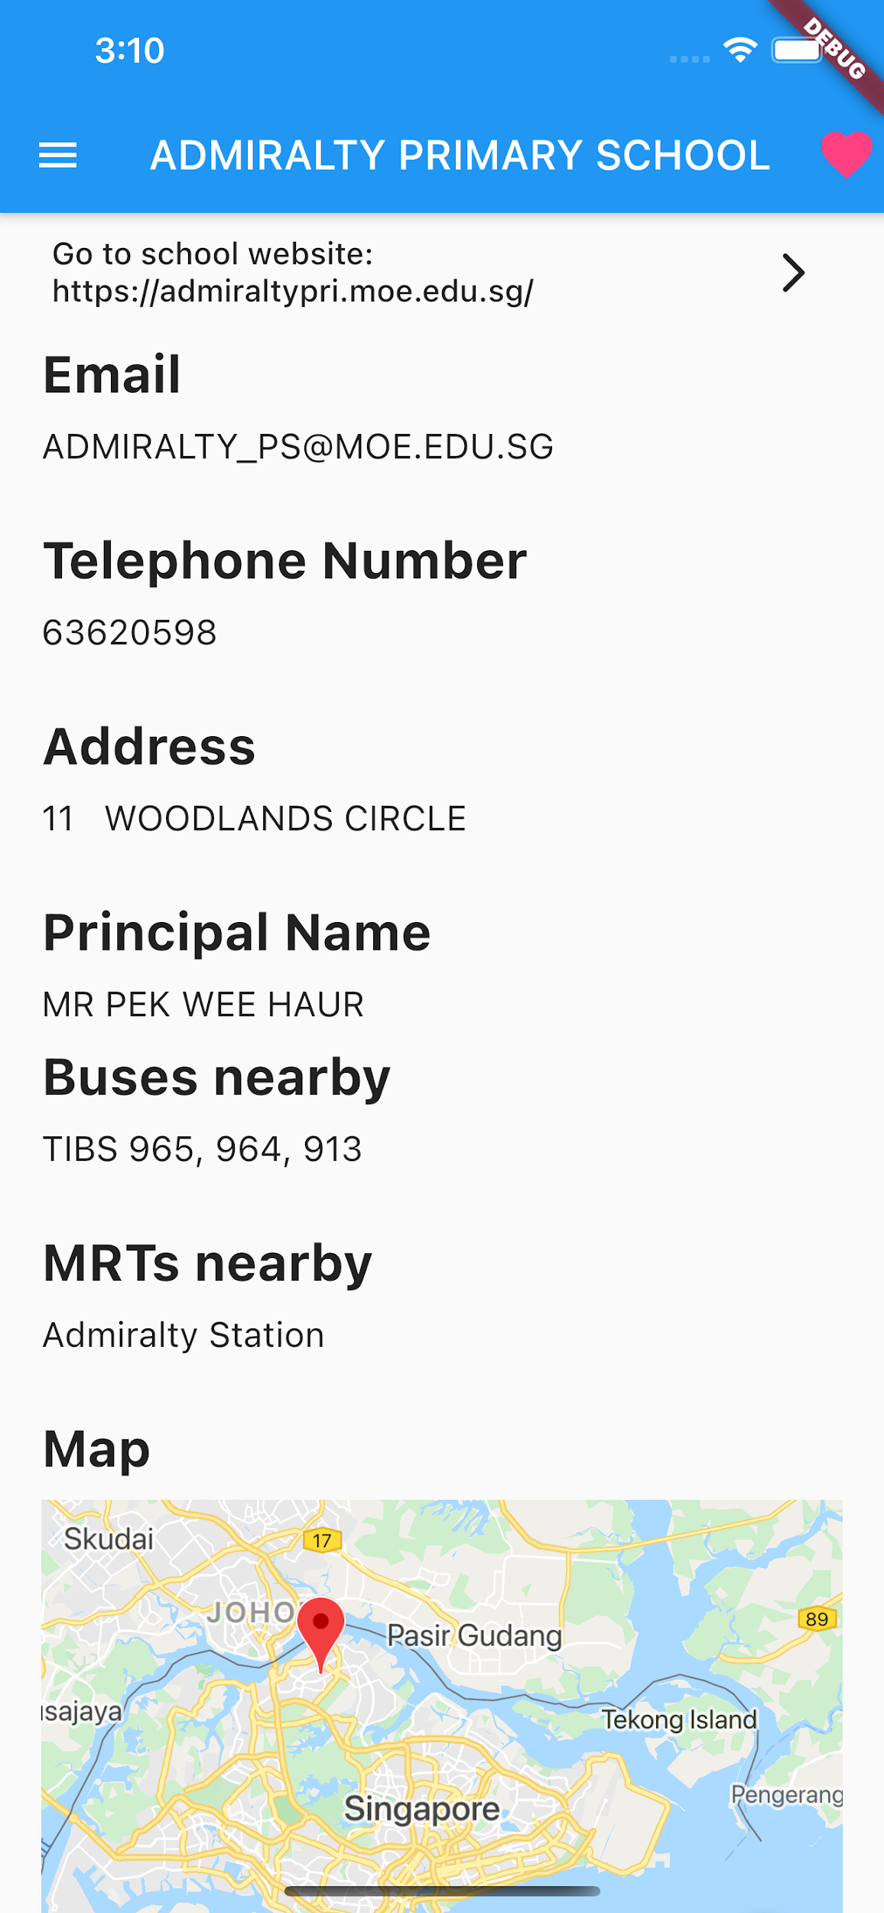

**More-info page(1):**

This page gives the details of the school selected by the user as well as access to the Drawer Navigator.

Also there is a like button at the top right and if the user clicks on it, it will add this school to the users’ Favourites list.

Here it is already highlighted as this school is already added to the users’ Favourites list. Pressing this button again will deselect the school and remove it from the user’s Favourite list.

**More-info page(2):**

This page is an extension to the previous More Info page. It displays the location of the school on a google map. The rating and comments button takes the user to the comments and rating page of the school.

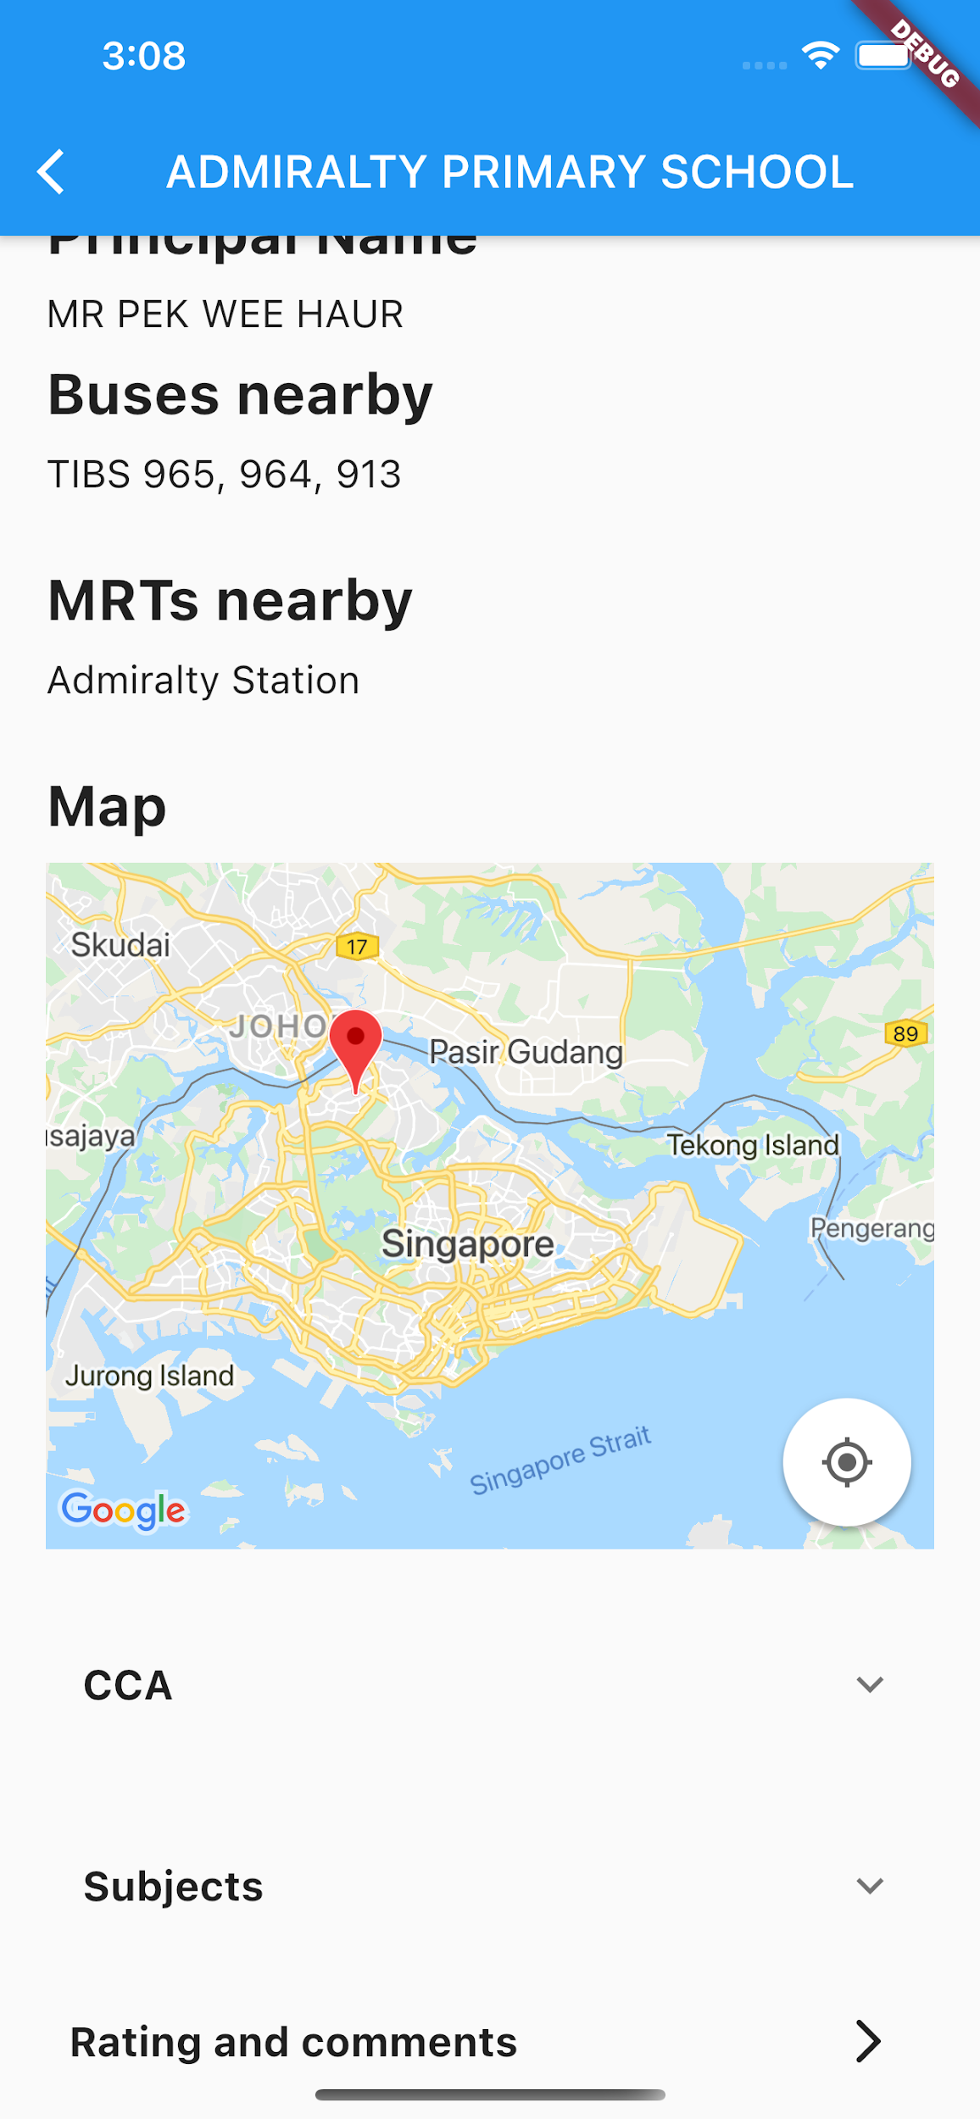

**Scenario 2: More info Page for guest users**

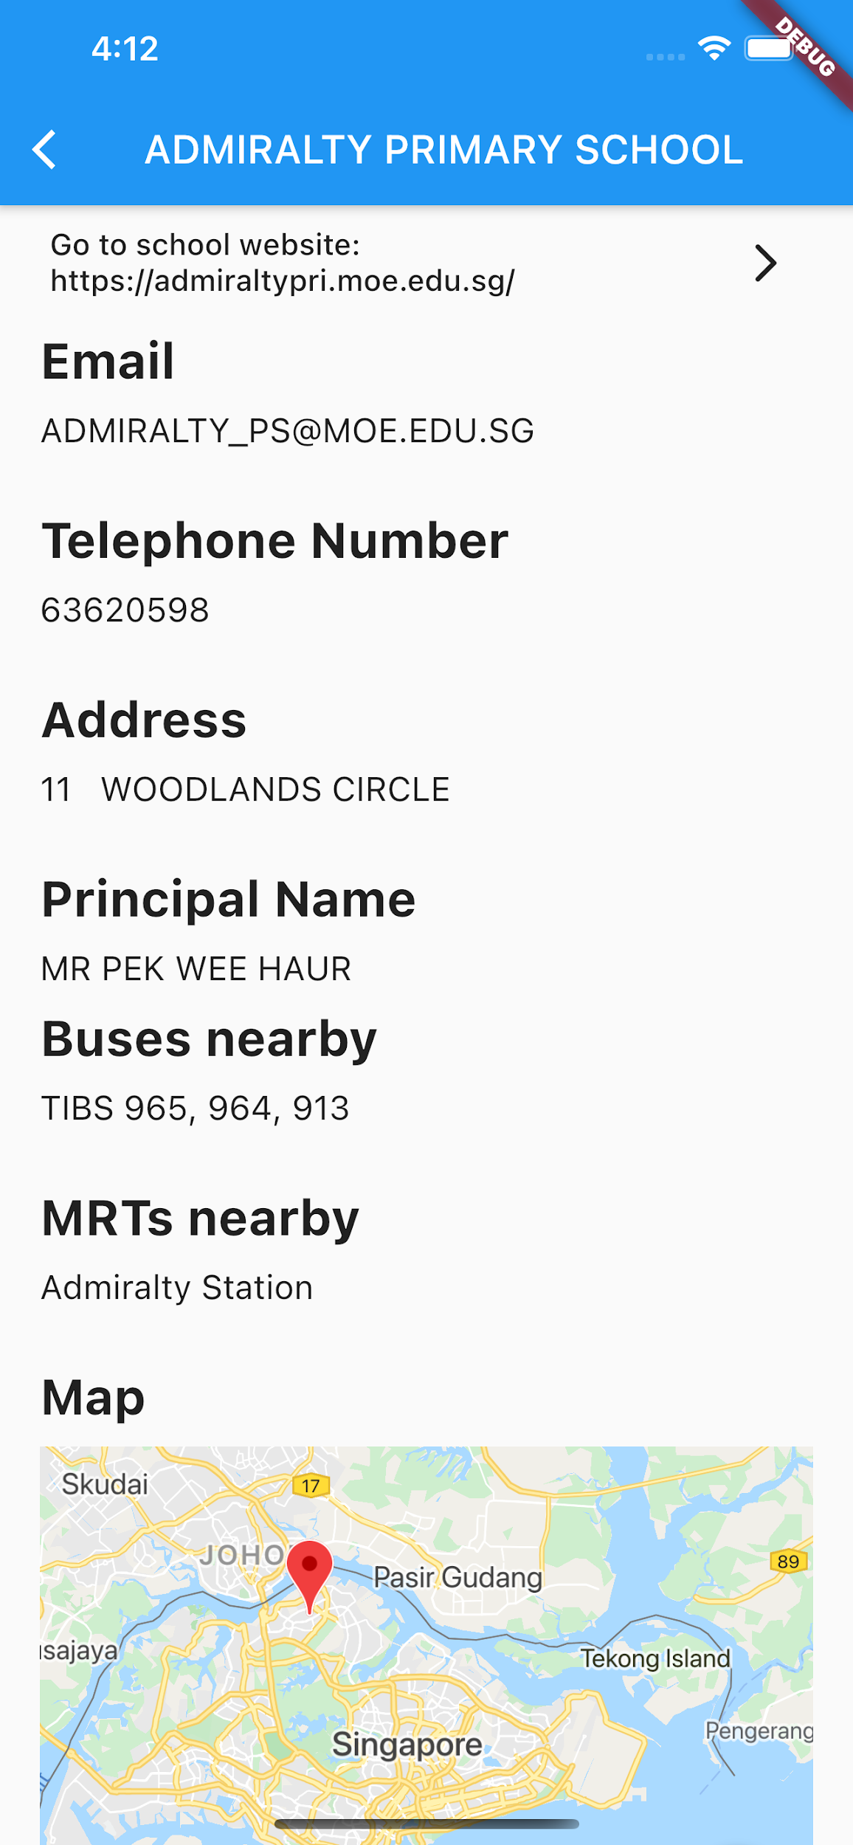

**More-info page(1):**

This page gives the details of the school selected by the user.

This gives the same info as the logged-in user but the guest user does not have access to the drawer navigator and the favourites button.

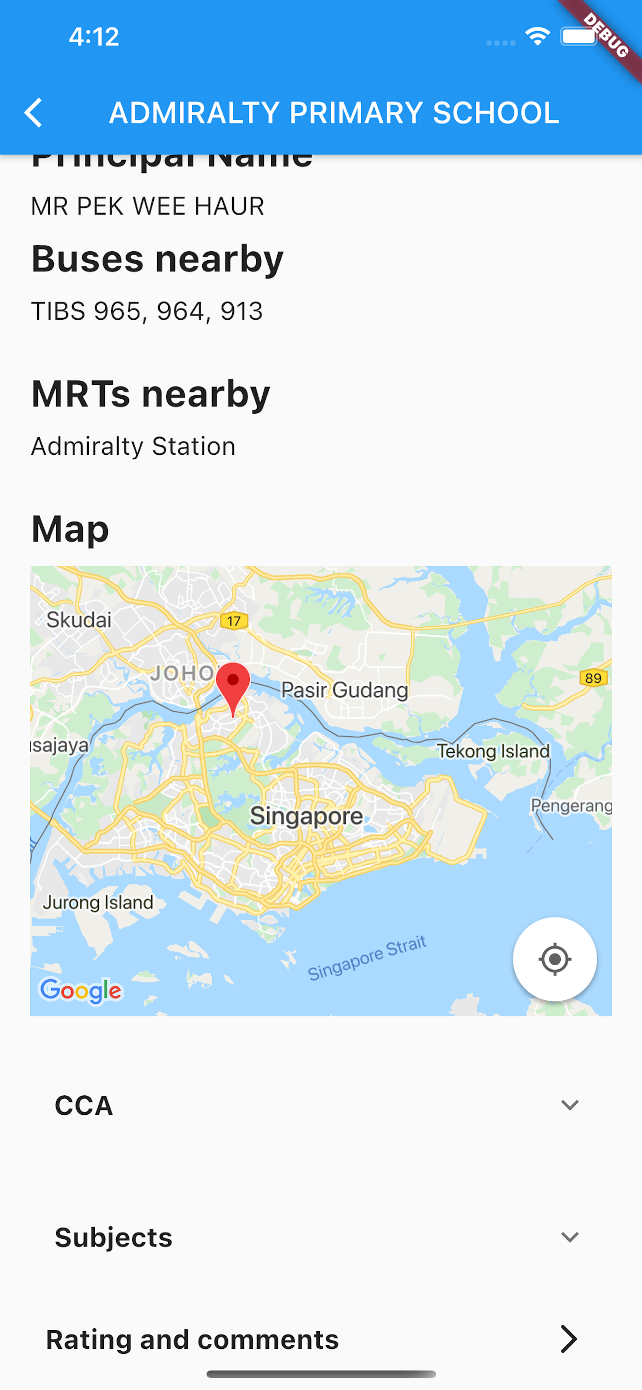

**More-info page(2):**

This page is an extension to the previous More Info page. It displays the location of the school on a google map. The rating and comments button takes the user to the comments and rating page of the school.

**Ratings and Comments Page**

**Scenario 1: Ratings and Comments Page for Logged in users**

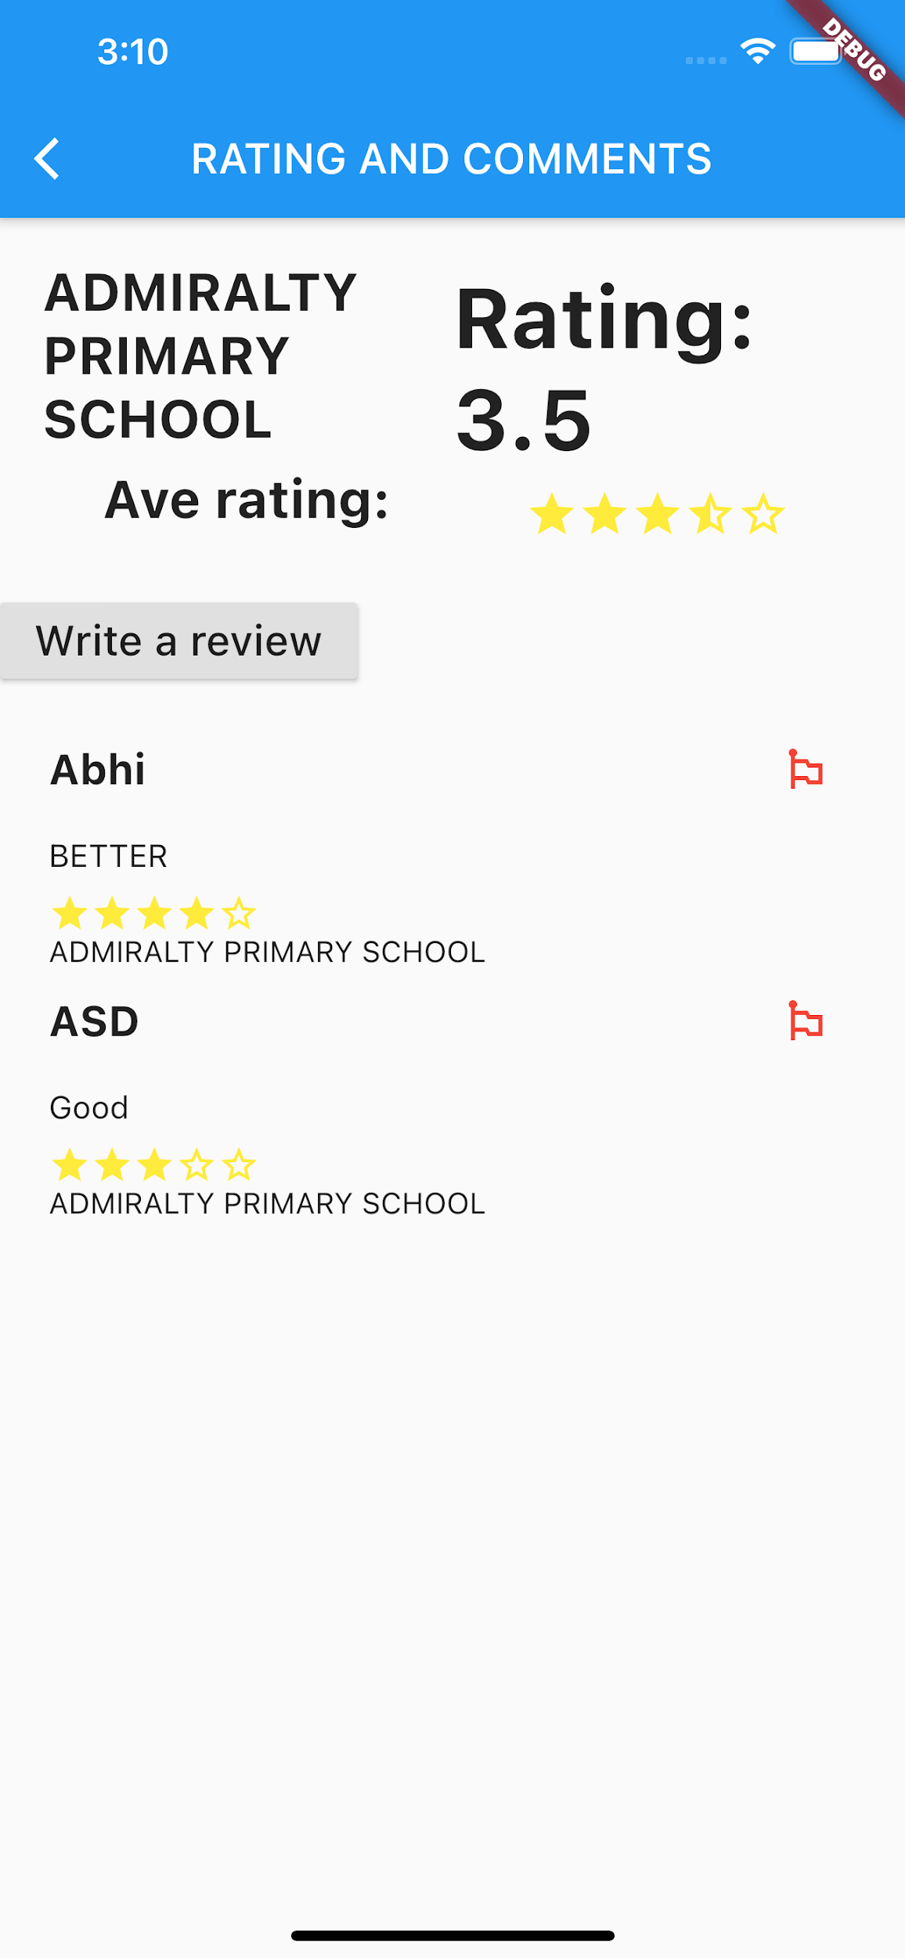

**Ratings and Comments Page:**

This page displays the average rating of the schools based on the reviews given by other users and the user can also access the comments given by them.

The user can write a review by clicking on the write a review button.

Users can also report a comment for being inappropriate by clicking on the flag button.

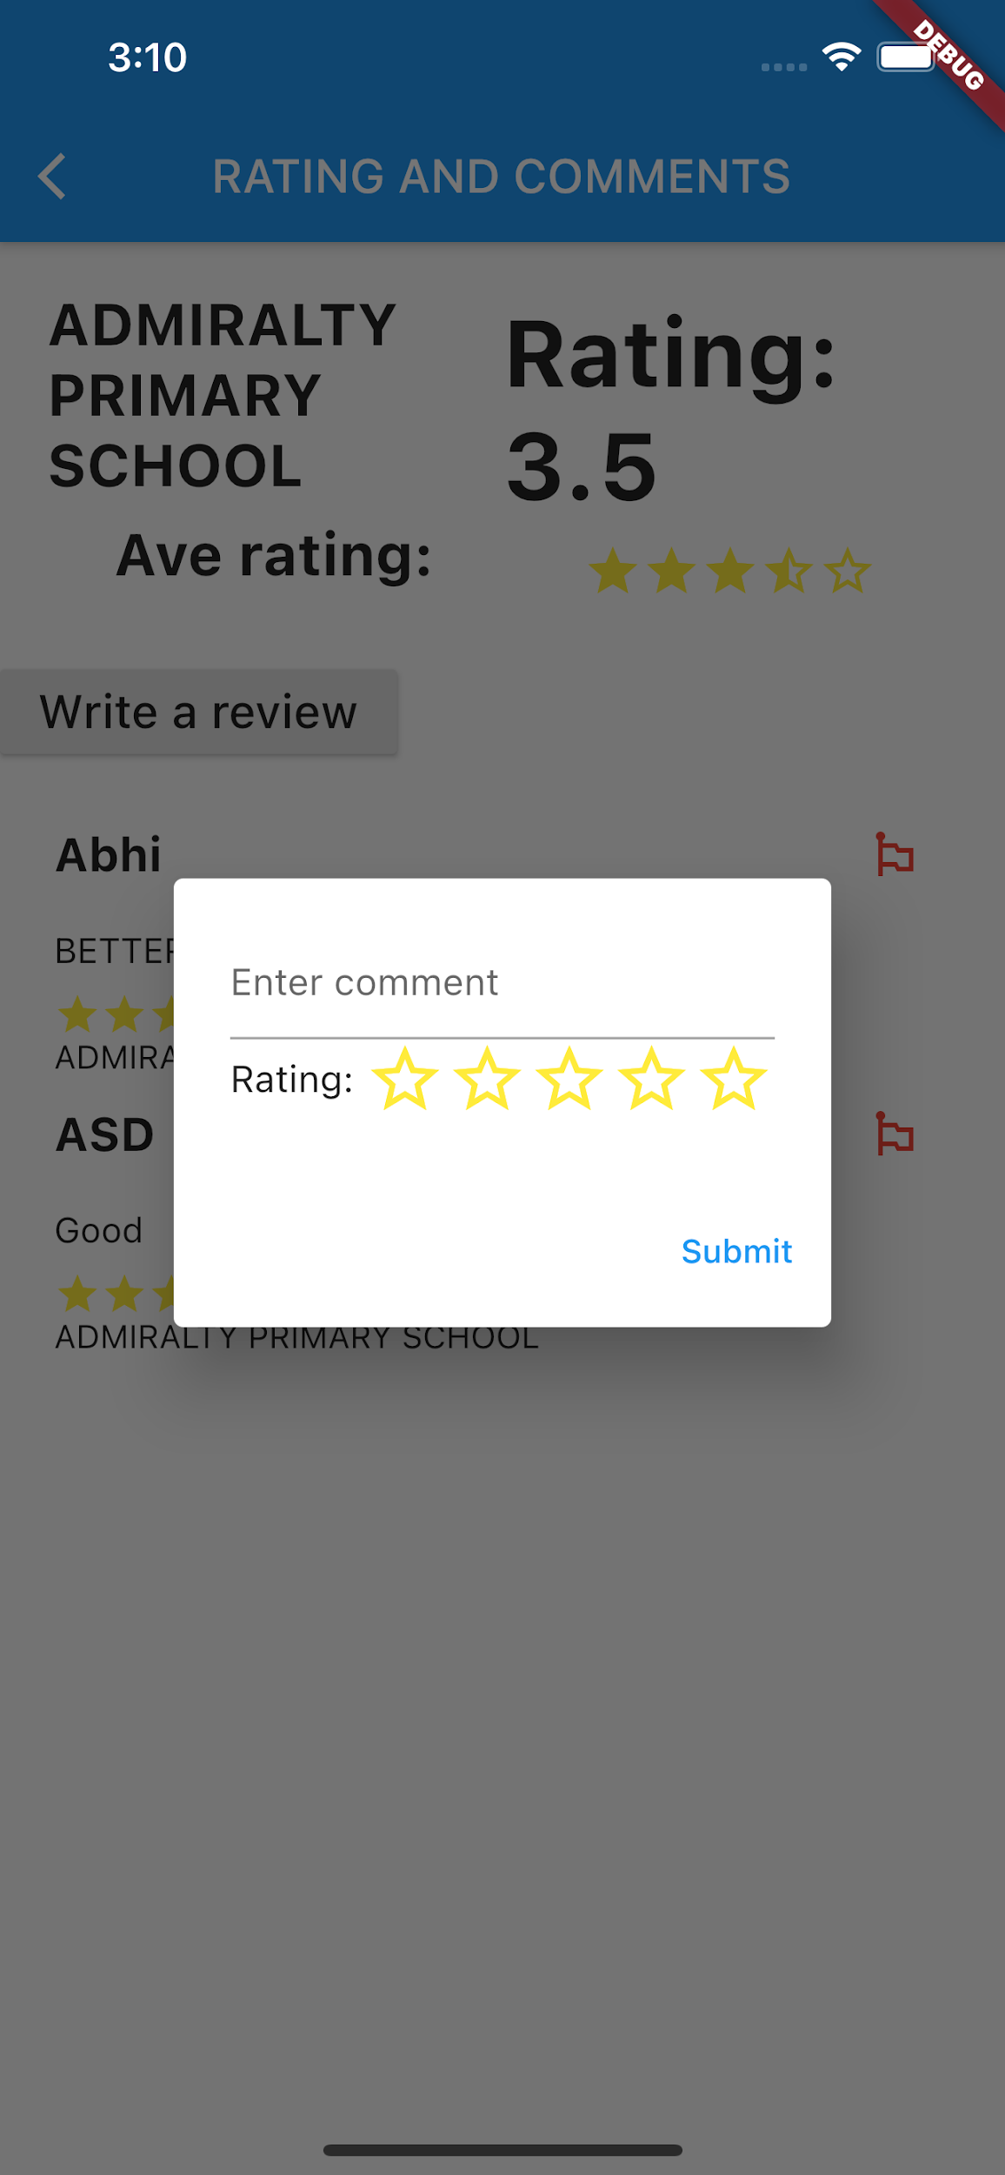

**Write a Review:**

The user can write a review for the school and also rate it using this dialogue box.

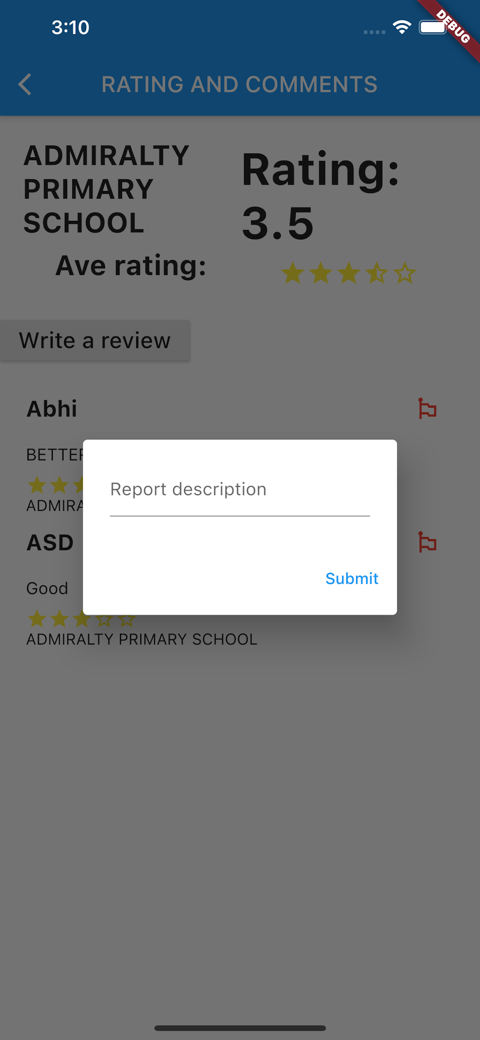

**Report:**

The user can report any comment for being inappropriate.

**Scenario 2: Ratings and Comments Page for guest users**

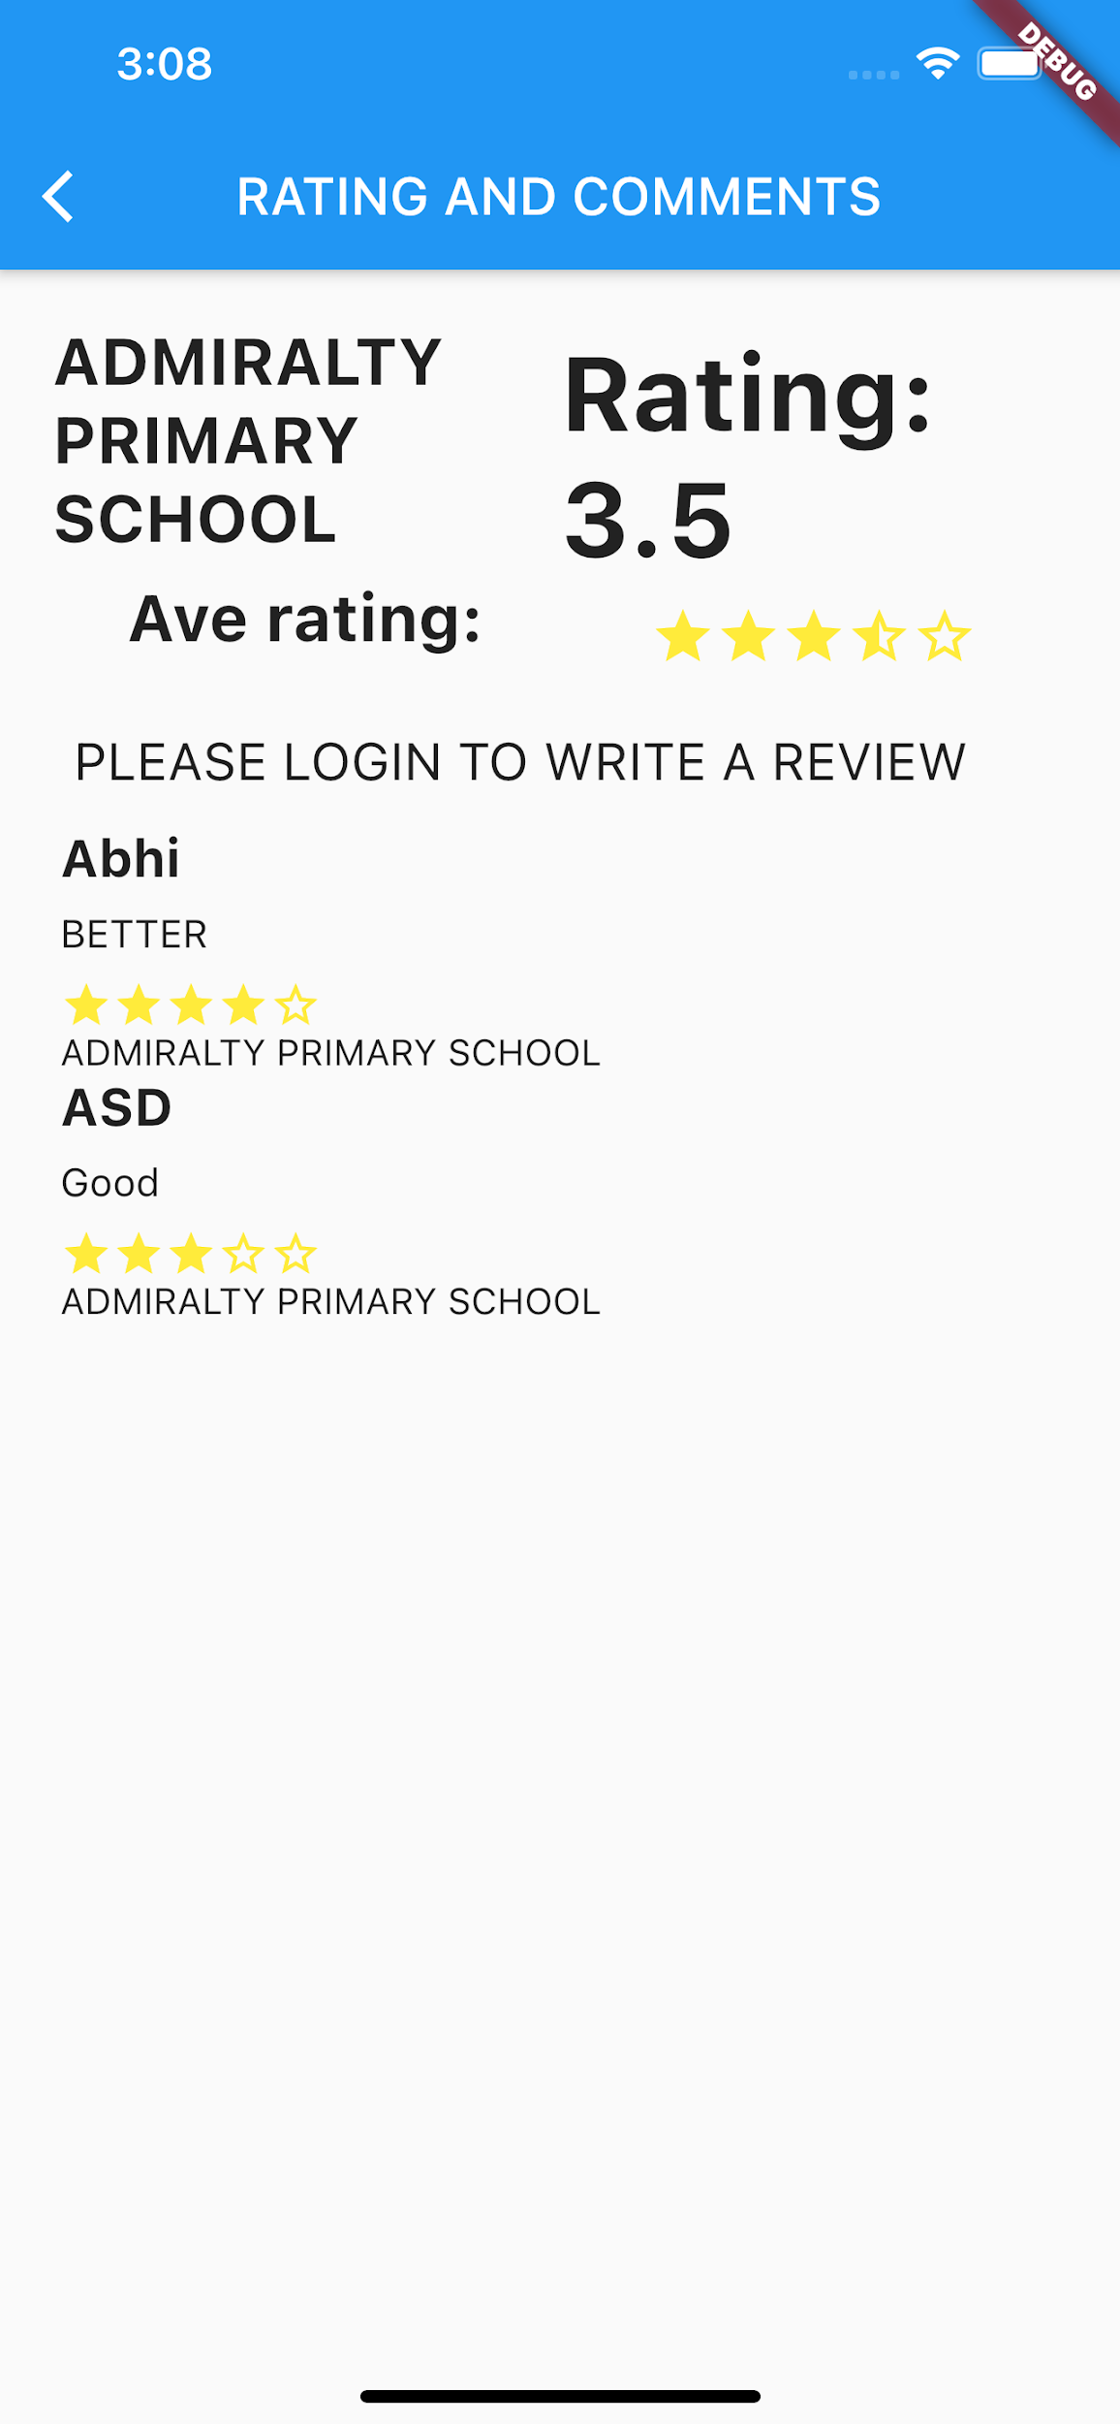

**Ratings and Comments Page:**

This page allows the guest user to read the comments and the average ratings for the school but they cannot write a review or report a comment.

## Hardware Interfaces

* IOS Phone/ Android Phone
* MySQL Database Server Machine - using XAMPP

## Software Interfaces

* Databases:
  + User-related: XAMPP on the server machine
  + Google Map: API
  + School: API from data.gov.sg
* App:
  + Version: 1.0.0+1
  + SDK: “>=2.7.0 <3.0.0”
* Libraries/Dependencies:
  + cupertino_icons: ^0.1.0
  + http
  + html
  + rect_getter: ^0.1.0
  + like_button: ^1.0.4
  + url_launcher: ^5.7.10
  + google_maps_flutter: ^1.0.3
  + geocoder
  + smooth_star_rating
  + flutter_string_encryption: ^0.3.1
  + mailer
  + geolocater

## Communications Interfaces

The interaction and communication with databases will be discussed in this section.

User-related Database Interaction

For this project, MySQL is used which is managed by phpMyAdmin. phpMyAdmin is a free and open source administration tool for MySQL. As a portable web app written primarily in PHP, it has become one of the most popular MySQL administration tools, especially for web hosting services. In total, 4 SQL databases are used to store the datas - Comments, Favourites, Reports and Users.

The model chosen for database interaction is a server client based model. The interaction between server and client is based on PHP. The PHP scripts have uploaded to the server and the interaction is facilitated by PhpMyAdmin which itself uses MySQL to handle the databases.

The choice of PHP was to reduce cost as it is open sourced. In addition, PHP based databases are platform independent and can be tested easily. The PHP files chosen to be included in this project are:

1. Userinfo.php
2. Reports.php
3. Favourite.php
4. comments.php

These files contain the basic SQL commands needed to provide the basic functionalities needed for the app.

For Users’ table, Username is set as the primary key and the attributes are Password, Email, PostalCode and Units.

USERS(Username, Password, Email, PostalCode, Units)

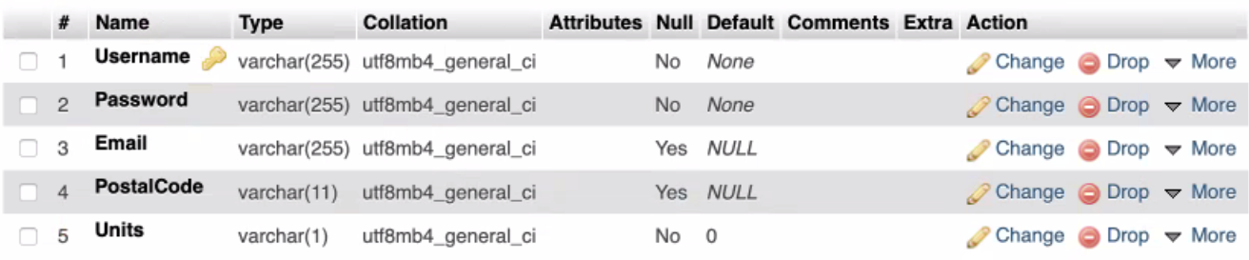

Fig 3: User Database

Referring to the above table, the values in Username, Message and Email are stored as string value while the values in PostalCode and Units are stored in integer value. To ensure no duplication in the database and keep the referential integrity, this table is in 3rd Normal Form. This is possible as there are no transitive functional dependencies in any of the non-key columns.

For comments’ table, Username is set as the primary key and the attributes are Message, SchoolName and Rating.

COMMENTS(Username, Message, SchoolName, Rating)

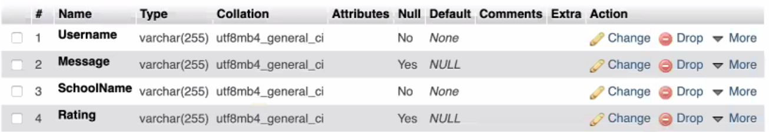

Fig 4: Comment Database

Referring to the above table, the values in Username, Message and SchoolName are stored as string and the values in Rating are stored as float. To ensure no duplication in our database and keep the referential integrity, this table is in 3rd Normal Form. This is possible as there are no transitive functional dependencies in any of the non-key columns.

For favourites’ table, Username is set as the primary key and the attribute is SchoolName.

FAVOURITES(Username, SchoolName)

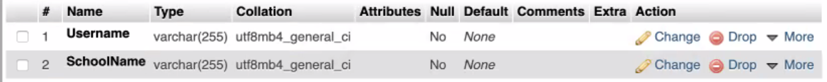

Fig 5: Favourites Database

Referring to the above table, the values in Username and SchoolName are stored as string. To ensure no duplication in the database and keep the referential integrity, this table is in 3rd Normal Form. This is possible as there are no transitive functional dependencies in any of the non-key columns.

For reports’ table, Username is set as the primary key. The attribute is Message.

REPORTS(Username, Message)



Fig 6: Report Database

Referring to the above table, the values in Username and Message are stored as string. To ensure no duplication in the database and keep the referential integrity, this table is in 3rd Normal Form. This is possible as there are no transitive functional dependencies in any of the non-key columns.

School’s Database Interaction

* HTTP Protocol: For interacting with the API and the database server

The http package in flutter allows data to be fetched from the internet through API calls. API is a one-way service that allows a server to send events to the client, using HTTP as a transport mechanism.

The school’s dataset is obtained from a public government website data.gov.sg which can be fetched using the API key provided. For this project, there are a total of 5 datasets to be fetched: General Information, Subjects, Co-Curricular Activities(CCA), MOE programmes and School Distinctive programmes. These data are parsed as JSON format for easier access to the required data features.

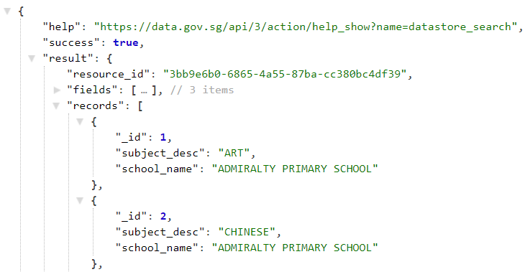

Fig 7: JSON File

Google Map API Interaction

For the Google Map API, a product key has to be obtained from Google Developer Console as shown below under meta-data.

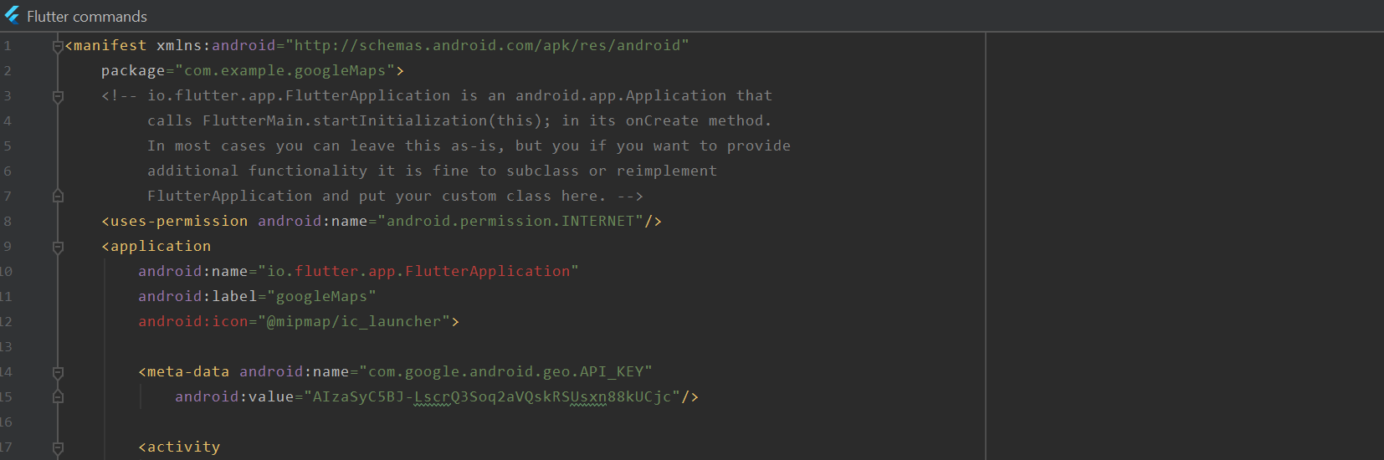

Fig 8: AndroidManifest.xml

It is then imported in the pubspec file as a dependency.

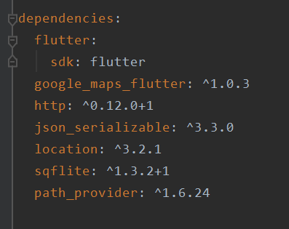

Fig 9: pubspec.yaml

Next, a Future function that makes use of the paid GoogleMaps function to be able to obtain the exact latitude and longitude for each and every school. For instance, ‘Hougang Primary School’ has a longitude and latitude of 1.37751 and 103.88090.

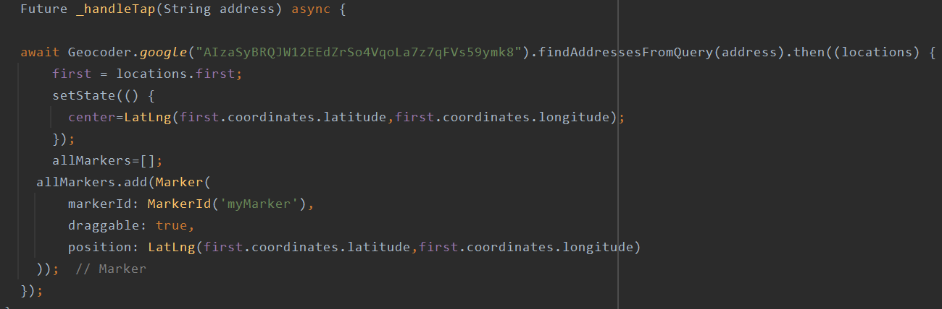

Fig 10: Geocoder Function

# System Features

## Login

|  |  |  |  |
| --- | --- | --- | --- |
| Use Case ID: | UC001 | | |
| Use Case Name: | Login | | |
| Created By: | Cheng Han | Last Updated By: | - |
| Date Created: | 01-02-21 | Date Last Updated: | - |

|  |  |
| --- | --- |
| Actor: | User, User database |
| Description: | Authenticate the user |
| Preconditions: | The user has downloaded and started the app |
| Postconditions: | 1. User is able to login. 2. User is unable to login. |
| Priority: | High |
| Frequency of Use: | High |
| Flow of Events: | 1. User inputs ‘USERNAME’ and ‘PASSWORD’. 2. User clicks the login button. 3. System interacts with the user database and authenticates the user. 4. User is logged in. |
| Alternative Flows: | AF1-S3: If the password is wrong   1. User is shown ‘INVALID LOGIN’.   AF2-S3: If the USERNAME is wrong   1. User is shown ‘INVALID LOGIN’. |
| Exceptions: | EX1: Local server storing the user database is down |
| Includes: | - |
| Special Requirements: | - |
| Assumptions: | All Servers are up and running with no connection problems. |
| Notes and Issues: | - |
| Functional Requirements: | |
| REQ-1: Users must be able to choose to login or use a guest account.  1.1 Registered users must be able to login.  1.1.1 Users must be able to sign out at any point in time.  1.1.2 System must be able to identify and prompt the user to re-enter their password if they entered it wrongly.  1.1.3 User must be able to regenerate the password via email if he/she forgets it  REQ-2: Information Databases  2.1 Database management systems must be able to retrieve the information needed when the app demands it.  2.1.1 Database must be able to store the login credentials.  2.2 Database management systems must be able to modify databases when the app has a new element to add to the database .  2.2.1 Database must be updated when a new user registered. | |

Table 3: Login

## Register

|  |  |  |  |
| --- | --- | --- | --- |
| Use Case ID: | UC002 | | |
| Use Case Name: | Register | | |
| Created By: | Boon Khang | Last Updated By: | - |
| Date Created: | 01-02-21 | Date Last Updated: | - |

|  |  |
| --- | --- |
| Actor: | User, User Database |
| Description: | Register user into user database. |
| Preconditions: | User does not have an account. |
| Postconditions: | User account is created. |
| Priority: | Medium |
| Frequency of Use: | Medium |
| Flow of Events: | 1. User selects the ‘REGISTER’ button. 2. User is prompted to enter ‘USERNAME’, ‘PASSWORD’ and ‘EMAIL’. 3. System checks whether the user is already registered. 4. System creates a new user. 5. User is prompted to login. |
| Alternative Flows: | AF-S3: If user already exist   1. System informs the user ‘USER ALREADY EXISTS’ 2. User is prompted to enter another email address. |
| Exceptions: | EX1: Local server storing the user database is down. |
| Includes: | - |
| Special Requirements: | - |
| Assumptions: | All Servers are up and running with no connection problems. |
| Notes and Issues: | - |
| Functional Requirements: | |
| REQ-1: Users must be able to choose to login or use a guest account.  1.1 Guest users must be able to register.  1.2.1 Username constraints  1.2.1.1 Username must be unique  1.2.2 System must be able to store newly created accounts.  REQ-2: Information Databases  2.1 Database management systems must be able to retrieve the information needed when the app demands it.  2.1.1 Database must be able to store the login credentials.  2.2 Database management systems must be able to modify databases when the app has a new element to add to the database .  2.2.1 Database must be updated when a new user registered. | |

Table 4: Register

## Favourite

|  |  |  |  |
| --- | --- | --- | --- |
| Use Case ID: | UC003 | | |
| Use Case Name: | Favourite | | |
| Created By: | Abhiyan Singh | Last Updated By: | - |
| Date Created: | 01-02-21 | Date Last Updated: | - |

|  |  |
| --- | --- |
| Actor: | User, Favourites Database |
| Description: | Add or remove a school from the Favourite Section. |
| Preconditions: | User is logged in. |
| Postconditions: | School is added in the Favourite Database. |
| Priority: | Low |
| Frequency of Use: | Low |
| Flow of Events: | 1. If the heart icon beside the name of the school is non-coloured, user clicks on the heart icon. 2. System stores the name of the school and username in the Favourites database. 3. The empty heart icon becomes pink in colour. |
| Alternative Flows: | AF1-S1: If the heart icon is already pink   1. System removes the school from the Favourites database. 2. Pink heart icon becomes empty. |
| Exceptions: | EX1: Local server storing the user database is down. |
| Includes: | - |
| Special Requirements: | - |
| Assumptions: | User is already logged in. |
| Notes and Issues: | - |
| Functional Requirements: | |
| REQ-1: Registered users have access to memory reliant features of the app.  1.1 Registered users must be able to save their preferred school under their favorite section for future reference.  REQ-2: Information Databases  2.1 Database management systems must be able to retrieve the information needed when the app demands it.  2.1.1 Database must be able to store the favourites, reviews, ratings and comments made by users.  2.2 Database management systems must be able to modify databases when the app has a new element to add to the database.  2.2.1 Database must be updated when a user adds the school to the favourites list. | |

Table 5: Favourite

## Report

|  |  |  |  |
| --- | --- | --- | --- |
| Use Case ID: | UC004 | | |
| Use Case Name: | Report | | |
| Created By: | Jonathan Yap | Last Updated By: | - |
| Date Created: | 01-02-21 | Date Last Updated: | - |

|  |  |
| --- | --- |
| Actor: | User, Report Database |
| Description: | User submits a report on abusive behaviour by other users |
| Preconditions: | User is logged in |
| Postconditions: | Report on abusive user is added to the report database |
| Priority: | Low |
| Frequency of Use: | Low |
| Flow of Events: | 1. The user clicks on the report button on another user’s review. 2. The user then types out a brief description on what the offending user did. 3. System stores the report into the database. |
| Alternative Flows: | - |
| Exceptions: |  |
| Includes: | EX1: Local server storing the user database is down. |
| Special Requirements: | - |
| Assumptions: | All Servers are up and running with no connection problems. |
| Notes and Issues: | - |
| Functional Requirements: | |
| REQ-1: Registered users must be able to report other users for inappropriate behaviour.  REQ-2: App must display the report comment icon for registered users.  2.1 App must display a pop-up window for report  2.1.1 Pop up window allows users to submit their report reasons in a text box.  2.1.2 Pop up window displays a “report” button to submit the reason to the system.  REQ-3: Information Databases  3.1 Database management systems must be able to retrieve the information needed when the app demands it.  3.1.1 Database must be able to store the reports made by the users.  3.2 Database management systems must be able to modify databases when the app has a new element to add to the database.  3.2.1 Database must be updated when a report is submitted. | |
|
|

Table 6: Report

## Review

|  |  |  |  |
| --- | --- | --- | --- |
| Use Case ID: | UC005 | | |
| Use Case Name: | Review | | |
| Created By: | Jia Le | Last Updated By: | - |
| Date Created: | 01-02-21 | Date Last Updated: | - |

|  |  |
| --- | --- |
| Actor: | User, Government Database, Comments Database |
| Description: | Post comment and rating for the school |
| Preconditions: | 1. User is logged in 2. User must be at the ‘MORE INFORMATION’ page. |
| Postconditions: | User comment and rating successfully posted. |
| Priority: | Medium |
| Frequency of Use: | Low |
| Flow of Events: | 1. User inputs personal comment. 2. User inputs rating. 3. User selects ‘SUBMIT’. 4. System gets the school name from the government database. 5. System stores comment and rating to the comments database with user name and school name as the key. 6. User is prompted that the comment and rating has been successfully posted. 7. Use case ends. |
| Alternative Flows: | - |
| Exceptions: | - |
| Includes: | - |
| Special Requirements: | - |
| Assumptions: | All Servers are up and running with no connection problems. |
| Notes and Issues: | - |
| Functional Requirements: | |
| REQ-1: Registered users have access to memory reliant features of the app.  1.1 Registered users must be able to leave a star rating on the schools in the system.  1.2 Registered users must be able to leave comments on the pages of the schools displayed.  REQ-2: App must display the ratings, review and comments that other users made for the school.  2.1 All reviews must be displayed with the registered user’s name and star rating of the school.  REQ-3: Information Databases  3.1 Database management systems must be able to retrieve the information needed when the app demands it.  3.1.1 Database must be able to store the reviews, ratings and comments made by users.  3.2 Database management systems must be able to modify databases when the app has a new element to add to the database.  3.2.1 Database must be updated when a review or comment is left on the school.  3.2.2 Database must be updated when a rating is left on the school. | |

Table 7: Review

## Search

|  |  |  |  |
| --- | --- | --- | --- |
| Use Case ID: | UC006 | | |
| Use Case Name: | Search | | |
| Created By: | Ying Sheng | Last Updated By: | - |
| Date Created: | 01-02-21 | Date Last Updated: | - |

|  |  |
| --- | --- |
| Actor: | User, Government API (Data.gov.sg), User database, Google API, comments API |
| Description: | Basic search for a specific school |
| Preconditions: | User is at the homepage |
| Postconditions: | Display the search results |
| Priority: | High |
| Frequency of Use: | High |
| Flow of Events | 1. User types in the name of the school to search for. 2. System interacts with the government API to retrieve a list of schools based on the input. 3. System displays a list of schools to the user. 4. User selects the ‘MORE INFORMATION’ button. 5. System retrieves school information from the government API and school’s reviews from the review database. 6. System displays the detailed school page. 7. User can read the reviews by the other users. |
| Alternative Flows: | AF1-S2: If no matching school is found.   1. System shows a “NO SCHOOL IS FOUND” message. 2. Return to step 1.   AF3-S6: If the user is logged in.   1. User can add the school as favourite (UC003) 2. User can post a review for the school (UC005). 3. User can report inappropriate comments (UC004). |
| Exceptions: | EX1: Local server storing the user database is down. |
| Includes: | - |
| Special Requirements: | - |
| Assumptions: | All Servers are up and running with no connection problems. |
| Notes and Issues: | - |
| Functional Requirements: | |
| REQ-1: Information on the school must be retrieved from the data.gov.sg website using an API.  1.1 App must display the list of schools by ascending alphabetical order.  1.1.1 App must allow users to scroll through the list manually.  1.1.2 App must allow users to select a school of their choice to view more information.  1.2 App must display the list of schools by ascending alphabetical order with respect to the filters the user has applied.  1.2.1 App must allow users to select a school of their choice to view more information.  1.3 App must display more information of whichever school the user selected.  1.3.1 App must allow users to scroll through the school’s displayed information.  1.3.2 App must display the address of the school.  1.3.3 App must display the CCAs of the school  1.3.3.1 App must display a drop-down box with the list of CCAs that are offered in the school.  1.3.4 App must display the user’s selected school’s location on Google Maps.  1.3.4.1 App must allow the users to drag and navigate around the map manually.  1.3.5 App must display the directions by mode of transport to get to the school.  1.3.5.1 App must display the buses to take to school.  1.3.5.2 App must display the MRTs to take to school.  1.3.6 App must display the ratings, review and comments that other users made for the school.  1.3.6.1 All reviews must be displayed with the registered user’s name and star rating of the school.  1.3.7 App must display the report comment icon for registered users.  1.3.7.1 App must display a pop-up window for report  1.3.7.1.1 Pop up window allows users to submit their report reasons in a text box.  1.3.7.1.2 Pop up window displays a “report” button to submit the reason to the system.  REQ-2: Guest must be able to access the basic non-memory reliant features of the application  2.1 Users must be able to perform searches for school.  2.1.1 Users must be able to search by name.  2.1.2 Users must be able to search by filtering their criteria.  2.1.2.1 Users must be able to filter by education level. (e.g. primary/secondary)  2.1.2.2 Users must be able to filter by subject. (e.g. english, additional mathematics, physics etc.)  2.1.2.3 Users must be able to filter by CCA. (e.g. basketball, badminton, swimming etc.)  REQ-3: Information Databases  3.1 Database management systems must be able to retrieve the information needed when the app demands it.  3.1.1 Database must be able to store the login credentials.  3.1.2 Database must be able to store the reviews, ratings and comments made by users.  3.1.3 Database must be able to store the reports made by the users. | |

Table 8: Search

## Advanced Search

|  |  |  |  |
| --- | --- | --- | --- |
| Use Case ID: | UC007 | | |
| Use Case Name: | Advanced Search | | |
| Created By: | Cheng Han | Last Updated By: | - |
| Date Created: | 01-02-21 | Date Last Updated: | - |

|  |  |
| --- | --- |
| Actor: | User, Government Database (Data.gov.sg), User database, Google API, comment database. |
| Description: | Advanced search with filters on CCAs, subjects |
| Preconditions: | User is at the homepage |
| Postconditions: | Displays a list of the schools which match the filters |
| Priority: | High |
| Frequency of Use: | High |
| Flow of Events: | 1. User clicks on the ‘ADVANCE SEARCH’ button. 2. User selects the filters they desire and press the ‘APPLY’ button. 3. System interacts with the government API to retrieve a list of schools based on the input. 4. System displays a list of schools to the user. 5. User selects the ‘MORE INFORMATION’ button. 6. System retrieves school information from the government API and school’s reviews from the review database. 7. System displays the detailed school page. 8. User can read the reviews by the other users. |
| Alternative Flows: | AF1-S3: If no matching school is found.   1. System shows a “NO SCHOOL IS FOUND” message. 2. Return to step 1.   AF3-S7: If the user is logged in.   1. User can add the school as favourite (UC003) 2. User can post a review for the school (UC005). 3. User can report inappropriate comments (UC004). |
| Exceptions: | EX1: Local server storing the user database is down. |
| Includes: |  |
| Special Requirements: | - |
| Assumptions: | All Servers are up and running with no connection problems. |
| Notes and Issues: | - |
| Functional Requirements: | |
| REQ-1: Information on the school must be retrieved from the data.gov.sg website using an API.  1.1 App must display the list of schools by ascending alphabetical order.  1.1.1 App must allow users to scroll through the list manually.  1.1.2 App must allow users to select a school of their choice to view more information.  1.2 App must display the list of schools by ascending alphabetical order with respect to the filters the user has applied.  1.2.1 App must allow users to select a school of their choice to view more information.  1.3 App must display more information of whichever school the user selected.  1.3.1 App must allow users to scroll through the school’s displayed information.  1.3.2 App must display the address of the school.  1.3.3 App must display the CCAs of the school  1.3.3.1 App must display a drop down box with the list of CCAs that are offered in the school.  1.3.4 App must display the user’s selected school’s location on Google Maps.  1.3.4.1 App must allow the users to drag and navigate around the map manually.  1.3.5 App must display the directions by mode of transport to get to the school.  1.3.5.1 App must display the buses to take to school.  1.3.5.2 App must display the MRTs to take to school.  1.3.6 App must display the ratings, review and comments that other users made for the school.  1.3.6.1 All reviews must be displayed with the registered user’s name and star rating of the school.  1.3.7 App must display the report comment icon for registered users.  1.3.7.1 App must display a pop-up window for report  1.3.7.1.1 Pop up window allows users to submit their report reasons in a text box.  1.3.7.1.2 Pop up window displays a “report” button to submit the reason to the system.  REQ-2: Guest must be able to access the basic non-memory reliant features of the application  2.1 Users must be able to perform searches for school.  2.1.1 Users must be able to search by name.  2.1.2 Users must be able to search by filtering their criteria.  2.1.2.1 Users must be able to filter by education level. (e.g. primary/secondary)  2.1.2.2 Users must be able to filter by subject. (e.g. english, additional mathematics, physics etc.)  2.1.2.3 Users must be able to filter by CCA. (e.g. basketball, badminton, swimming etc.)  REQ-3: Information Databases  3.1 Database management systems must be able to retrieve the information needed when the app demands it.  3.1.1 Database must be able to store the login credentials.  3.1.2 Database must be able to store the reviews, ratings and comments made by users.  3.1.3 Database must be able to store the reports made by the users. | |

Table 9: Advanced Search

## More Information

|  |  |  |  |
| --- | --- | --- | --- |
| Use Case ID: | UC008 | | |
| Use Case Name: | More Information | | |
| Created By: | Boon Khang | Last Updated By: | - |
| Date Created: | 01-02-21 | Date Last Updated: | - |

|  |  |
| --- | --- |
| Actor: | User, Government Database (Data.gov.sg), Google API, Comment Database |
| Description: | More information on the specified school |
| Preconditions: | System has generated a list of schools |
| Postconditions: | Displays a detailed school page |
| Priority: | Medium |
| Frequency of Use: | Medium |
| Flow of Events: | 1. User selects a school from the list by clicking on the ‘MORE INFORMATION’ button. 2. System retrieves school information from the government API and school’s reviews from the review database. 3. System displays the detailed school page. |
| Alternative Flows: | - |
| Exceptions: | EX1: Local server storing the user database is down. |
| Includes: | - |
| Special Requirements: | - |
| Assumptions: | All Servers are up and running with no connection problems. |
| Notes and Issues: | - |
| Functional Requirements: | |
| REQ-1: Information on the school must be retrieved from the data.gov.sg website using an API.  1.1 App must display the list of schools by ascending alphabetical order.  1.1.1 App must allow users to scroll through the list manually.  1.1.2 App must allow users to select a school of their choice to view more information.  1.2 App must display the list of schools by ascending alphabetical order with respect to the filters the user has applied.  1.2.1 App must allow users to select a school of their choice to view more information.  1.3 App must display more information of whichever school the user selected.  1.3.1 App must allow users to scroll through the school’s displayed information.  1.3.2 App must display the address of the school.  1.3.3 App must display the CCAs of the school  1.3.3.1 App must display a drop down box with the list of CCAs that are offered in the school.  1.3.4 App must display the user’s selected school’s location on Google Maps.  1.3.4.1 App must allow the users to drag and navigate around the map manually.  1.3.5 App must display the directions by mode of transport to get to the school.  1.3.5.1 App must display the buses to take to school.  1.3.5.2 App must display the MRTs to take to school.  1.3.6 App must display the ratings, review and comments that other users made for the school.  1.3.6.1 All reviews must be displayed with the registered user’s name and star rating of the school.  1.3.7 App must display the report comment icon for registered users.  1.3.7.1 App must display a pop-up window for report  1.3.7.1.1 Pop up window allows users to submit their report reasons in a text box.  1.3.7.1.2 Pop up window displays a “report” button to submit the reason to the system.  REQ-2: Information Databases  2.1 Database management systems must be able to retrieve the information needed when the app demands it.  2.1.1 Database must be able to store the reviews, ratings and comments made by users.  2.1.2 Database must be able to store the reports made by the users.  2.2 Database management systems must be able to modify databases when the app has a new element to add to the database.  2.2.1 Database must be updated when a new user registered.  2.2.2 Database must be updated when a review or comment is left on the school.  2.2.3 Database must be updated when a rating is left on the school. | |

Table 10: More Info

# Other Nonfunctional Requirements

## Performance Requirements

1. The app must be able to produce query results within 10 seconds.
2. The app must be maintainable.

2.1. The app should run smoothly and not crash frequently.

2.2. The app must be separated between front-end and back-end to allow the admin to update the back end without interrupting the user.

3. The database must be able to support the data of 200 users but must be scalable for high demand use.

4. The app must be functional 24/7, 365 days a year..

## Safety Requirements

1. The user should exercise caution when using the app while driving or crossing the road.

## Security Requirements

1. The app must have reliable data.

1.1. The app must retrieve the newest data available on the government website through the API whenever the user tries to query the app.

2. The app must be secure while saving the users details.

2.1. The app must encrypt the user password when saving in the database.

## Software Quality Attributes

1. The app must be maintainable.

1.1. The app should run smoothly and not crash frequently.

1.2. The app must be separated between front-end and back-end to allow the admin to update the back end without interrupting the user.

2. The app’s interface must be user friendly.

2.1. The app must have hints wherever user input is required.

2.2. The app must guide the user whenever an invalid input is entered.

2.3. The registered users must be able to report or provide feedback on system errors.

3. The app must be portable and be able to work on both IOS and Android systems.

4. The app must be available at all times, less there is maintenance on the database fetched through APIs from public sources (e.g. Google Map and data.gov.sg)

5. The following app’s features must be loosely coupled and reusable in future projects.

5.1. An email notification containing a new password is sent to the user when the user clicks on “forget password”.

5.2. The password keyed in by the user is hashed to ensure security and privacy.

5.3. The user’s login credentials are encrypted in the user’s database to ensure security and privacy.

## Business Rules

1. The app should comply with regulation from data.gov website.
2. The registered user must be able to report, comment and favourite schools.
3. The guest user must not be able to report, comment and favourite schools.
4. Admin must be able to view the reports made and be able to delete comments.

# Appendix A: Glossary

**Data Dictionary**

|  |  |
| --- | --- |
| **Term** | **Definition** |
| User | The user of the app. There are two type of user:   1. User that had an registered account on our app 2. Guest user that use the app without signing in |
| Username | A name user used to log in to their registered account |
| User password | A password user used to log in to their registered account |
| School Name | Name of the school. |
| School Address | Address of the school |
| School description | A short history of the school and a little information about the number of staff, number of students, and achievement of the school. |
| Criteria | The criteria of a school such as the level of the school (secondary or primary), Subjects offered by the school, CCA, Special programme, Cut off Points, distance, postal code |
| Education Level | The type of the school whether the school provide education for primary students which the students are between age of 7 to 12 or secondary school student which the students are between age of 13 to 18 |
| Subjects | A subject is a basic unit of teaching. A subject offered by a school must be a subject listed in MOE. |
| CCA | Co-Curriculum activities are non-academic activities offered by the school, which aim to develop and enhance students’ leadership and communication abilities. |
| Special Programme | A special programme is a special program or training for students with outstanding academic results to prepare the students to participate in some international competition such as Math Olympiad, Physic Olympiad, IOI. |
| Cut Off Points | The minimum PSLE score (or the latest exam score) for a student to enrol in the school. |
| Preferred School/ Favourite School | A school in the list for which the user likes and add into their list of favourite schools. |
| Rating | A rating system for a user to rate for the quality of the school and the overall service and management of their experiences with the school. |
| Mode of transportation | The type of public vehicles that a user can take to reach the school, such as MRT or SMRT/SBS buses. |
| Report | A warning message sent by a user to indicate or alert the system about inappropriate comments or spam posted by the other users. |

# Appendix B: Analysis Models

*Refer to the documents attached together in the folder for all supporting diagrams (e.g. Class Diagrams, Sequence Diagrams, Initial Dialog Map)

**Class Diagram**

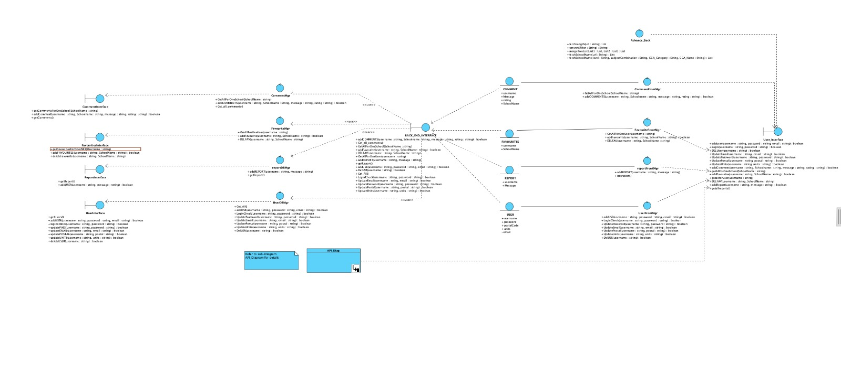

**API Diagram**

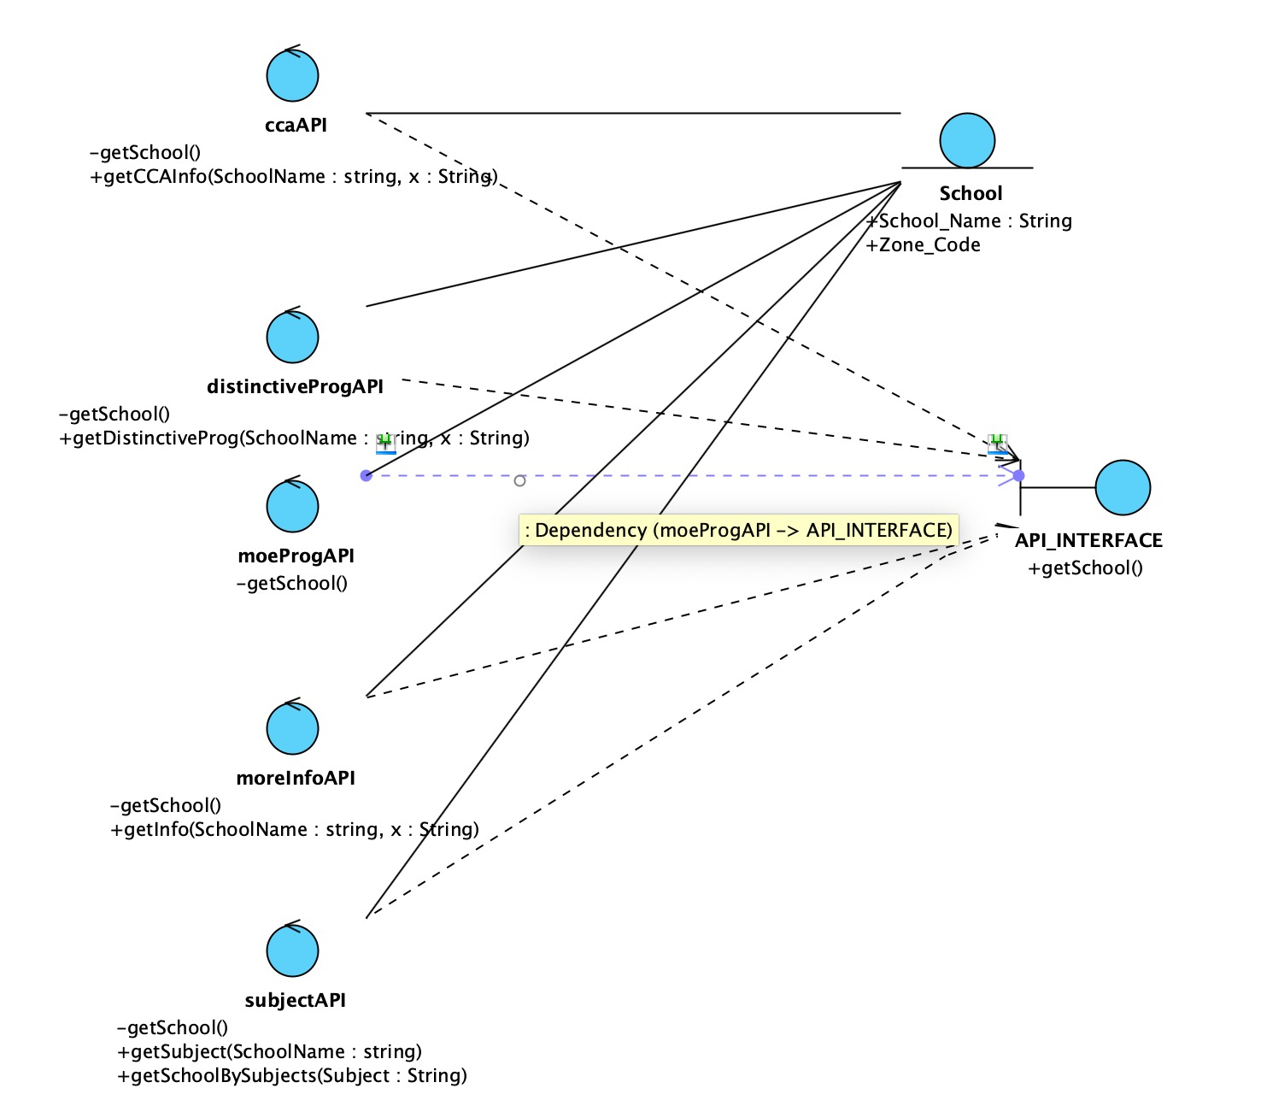

# Appendix C: User Manual

|  |  |
| --- | --- |
| **User Manual** | |
| Screens | User’s Action |
|  | 1)  User open ‘**Default’ page** at SchoolFinder in Phone.  User can select  **‘Login’ button, ‘Sign Up’ button** or **‘Guest User’ button**.  Click **‘Login’ button** at ‘**Default’ page** to navigate to **‘Login’ page** if the user has an account.  Click **‘Sign Up’ button** at ‘**Default’ page** to navigate to **‘Sign up’ page** if the user does not have an account and wants to create an account.  Click **‘Guest User’ button** to navigate to **‘Home’ page** if user wants to access the app.  2)  User selects **‘Sign Up’ button**, **‘Sign Up’ page** will appear.  User enters desired **Username, Password** and **Email**.  Click **‘Confirm’ button** in order to navigate to **‘Login’ page** after user has entered the relevant details. |

|  |  |
| --- | --- |
| **User Manual** | |
| Screens | User’s Action |
|  | 3)  User selects **‘Login’ button**, **‘Login’ page** will appear,  User enters **Username** and **Password**,  Click **‘Confirm’ button** to navigate to **‘Home’ page**,  Click **‘Cancel’ button** to navigate to **‘Default’ page**,  Click **‘Forget Password?’ button** to navigate to **‘Default’ page**,  Click **‘Don’t have an account? Sign Up’ button** to navigate to **‘Sign Up’ page**.  4)  User selects **‘Guest User’ button**, **‘Home’ page** will appear.  Click **‘Enter a search term...’ button** to navigate to **‘Search’ page**.  Click **‘Advance Search’ button** to navigate to **‘Advanced Search’ page**. |
|
|

|  |  |
| --- | --- |
| **User Manual** | |
| Screens | User’s Action |
|  | 5)  User selects **‘Enter a search term...’ button**, **‘Search’ page** will appear.  User can click on desired **School Name** to navigate to **‘More-info’ page**.  6)  User selects **‘Advance Search’ button**, **‘Advanced Search’ page** will appear.  User can select  **‘Primary’ button, ‘Secondary’ button** , **‘Junior College’** or **‘Mixed Levels’ button**.  User can select desired **Subject Combination** in the drop-down box.  User can select on desired **Category** and **Name**.  Click **‘Search’ button** in order to navigate to filtered **‘Search’ page**. |
|

|  |  |
| --- | --- |
| **User Manual** | |
| Screens | User’s Action |
|  | 7)  User selected School information will appear.  Click ‘**Right Arrow’ button** beside school website to visit school website.  Click **‘Rating and comments’ button** in order to navigate to ‘**Ratings and Comments’ Page**.  Click **‘Heart’ button** on top right corner to add the school to favourites.  8)  User selects **‘Ratings and Comments’ button**, **‘Ratings and Comments’ page** will appear.  Click **‘Write a Review’ button** to write a review.  Click **‘Red Flag’ button** to report other users. |

|  |  |
| --- | --- |
| **User Manual** | |
| Screens | User’s Action |
|  | 9)  User selects **‘Drawer Navigation’ button**, **‘Drawer Navigation’ page** will appear.  Click ‘**Home’ button** to visit **‘Home’ Page**.  Click **‘Favourites’ button** in order to view Favourite List.  Click **‘List of School’ button** in order to view all the schools.  Click **‘Setting’ button** in order to Change Password, Email or Postal Code.  Click **‘Sign Out’ button** to log out of account. |